Lillian (Robison) Tope
February 21, 1898 – March 2, 1963

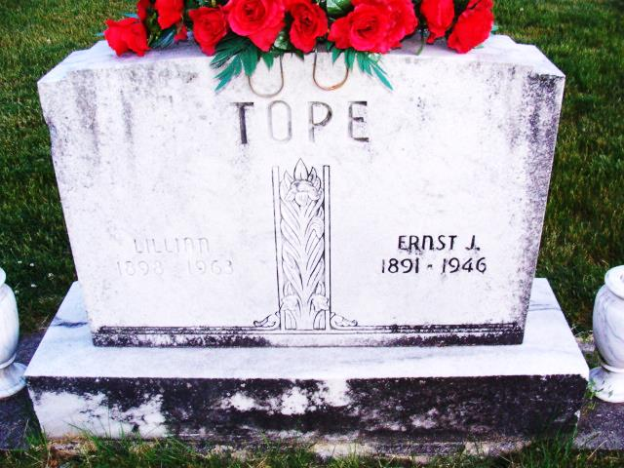
Photo by Alicia Kneuss

Mrs. Lillian Tope Is Taken By Death

Mrs. Ernest (Lillian) Tope, 65, of 806 Washington street, died at 12:18 o’clock Saturday afternoon at the Adams county memorial hospital following a day’s illness of complications.
She was born in Adams county Feb. 21, 1898, a daughter of Isaac and Sarah Ann Venis –Robison, and was married to Ernest Tope May 30, 1917. Her husband preceded her in death.
Surviving are one daughter, Mrs. Irene Dye of Decatur; three grandchildren, and one brother, Lester Robison of near Geneva. One brother is deceased.
Funeral services will be conducted at 2:30 p.m. Tuesday at the Winteregg-Linn funeral home, the Rev. Gerald Gerig officiating. Burial will be in the Decatur cemetery. Friends may call at the funeral home until time of the services. (Mon. March 4, 1963)

Berne Library Heritage Room
Adams County (IN) Obits 1958-1962
Transcribed by Janice Vasilovski

