Pvt. Richard L. Tope
July 20, 1920 – August 12,1944

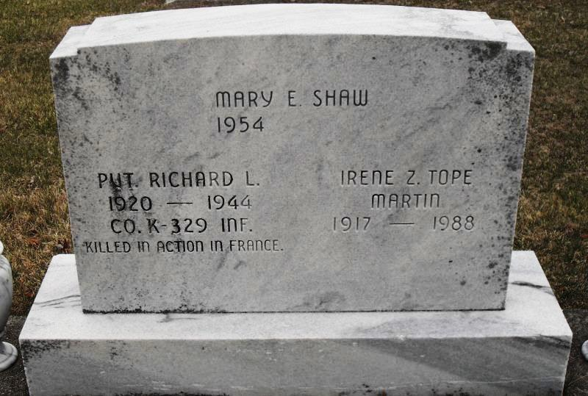
Photo by Stephen & Andrea Brangan

PVT. RICHARD TOPE REPORTED KILLED IN ACTION IN FRANCE

Pvt. Richard L. Tope, 24, only son of Mr. and Mrs. Ernest Tope, 806 Washington street, was killed in action in France on August 12, the war department notified the parents this morning.
The Decatur infantryman went overseas only last July. He entered the army December 10, 1943 and took basic training at Fort McClellan, Ala. He was stationed in England before going to France and presumably was in that country only a few days before meeting his death on the battlefield.
Prior to entering the service he was employed by the Bellmont Trucking company in this city. He had attended the Decatur high school and was born in this city, July 26, 1920.
Surviving besides the parents is a sister, Miss Irene Tope at home.

Decatur Daily Democrat, Adams County, Indiana; Saturday, Aug. 26, 1944

Contributed by Karin King

