Dolores JoAn (Sheets) Tschannen
November 16, 1930 – February 18, 2012

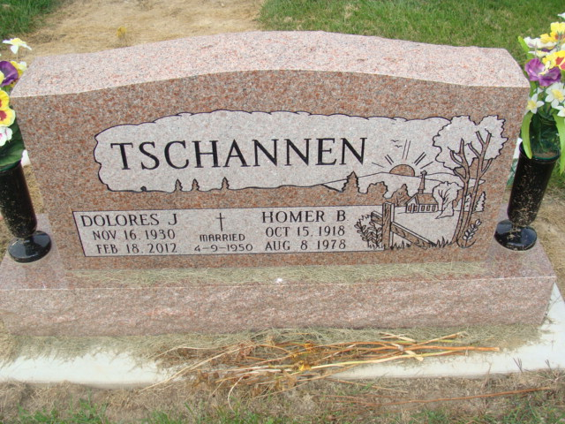
Photo by Alicia Kneuss

Dolores J. Tschannen, 81, of Decatur, IN passed away at 8:37 a.m. on Saturday, February 18, 2012 at Woodcrest Nursing Center. She was born on November 16, 1930 in Adams County, IN to the late Chalmer K. and Melvena M. (Smitley) Sheets. She married Homer B. Tschannen on April 9, 1950; he died on August 8, 1978.
She is survived by 3 daughters Mrs. Leonard (Linda) Schwartz of Berne, IN, Mrs. Paul (Barbara) Brown and Mrs. Jim (Rebecca) Cochran both of Decatur; 2 brothers Max Sheets of Lima, OH and Lester Sheets of Monroe, IN; 2 sisters Mrs. Bill (Mary) McCarty of Cutler, IN and Mrs. Richard (Carolyn) Marbaugh of Decatur; 5 grandchildren Benjamin (Samantha) Fawbush, Megan Fawbush, Jennifer (Marcus) Geers, Kristen Cochran, and Brittany Cochran; 2 adopted grandchildren Charles Seip, Lucie (Bob) Ordway; 2 great grandchildren Kolten and Ryne Fawbush. She was preceded in death by her adopted daughter Lupe Seip, a brother Jay Sheets, 5 sisters Josephine Weldy, Betty Overholser, Esther Peterson, Sally McDonough, and Faye Ann Sheets. Dolores was a member of Union Chapel United Methodist Church where she also was a member of the United Methodist Women, Work & Win Sunday School, and served as Chair of the Pastor Parish Committee. She worked as a homemaker and enjoyed babysitting.
Visitation will be from 3:00 – 8:00 p.m. on Tuesday, February 21, 2012 at Haggard Sefton & Hirschy Funeral Home. Funeral Service will be held at 10:00 a.m. on Wednesday, February 22, 2012 at Haggard Sefton & Hirschy Funeral Home. Officiating will be Pastor Ed Karges and burial will take place in the Decatur Cemetery. Memorials may be made to Union Chapel United Methodist Church.

Haggard-Sefton & Hirschy Funeral Home online obit (accessed February 19, 2012)

