Forest E. “Cy” Vail
August 29, 1894 – June 23, 1972

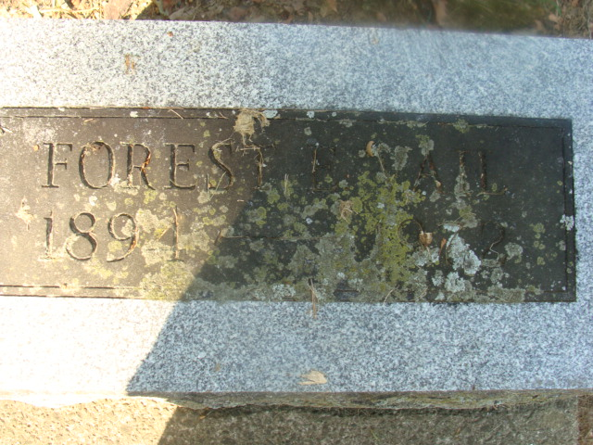
Photo by Alicia Kneuss

CY VAIL, AGE 77, DIES AT HOSPITAL

Forest (Cy) Vail, 77, of North Webster, route 1, a native of Decatur and a member a prominent Adams county family, died at 9 a.m. today at the Parkview memorial hospital, Fort Wayne. Death followed an extended illness of complications.
He was born in Decatur August 29, 1894, a son of John W. and Christine Railing-Vail and was married to Grace Butler April 20, 1916.
Mr. Vail was associated with the lumber business most of his life, moving from Louisiana to North Webster in 1940. For the past 20 years he had been associated with McGregor Golf, a division of Brunswick Corp.
He was a member of the Simpson United Methodist church in Fort Wayne, and served as executive secretary of the Indiana PGA from 1959 to 1969.
Surviving are wife and several nieces and nephews.
Funeral services will be conducted at 1 p.m. Monday at the Harris-Troxel funeral home in North Webster, with Rev. John Weeks officiating. The body will be brought to this city for burial in the Decatur cemetery. Friends may call at the funeral home from 2 to 4 and 7 to 9 p.m. Sunday.

Decatur Daily Democrat, Adams County, Indiana; Friday, June 23, 1972

Contributed by Karin King

