Larry Gene Werling
February 9, 1949 – December 2, 1966

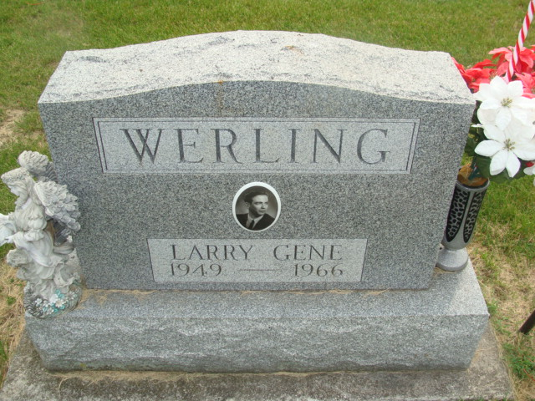
Photo by Alicia Kneuss

Three Decatur high school ... when passenger train

Three Decatur high school seniors en route to their parttime employment at the Krick-Tyndall Tile Co. were killed instantly when a westbound Erie Lackawanna railroad passenger train smashed into their car at the Tenth street crossing in Decatur Friday at 4:51 p.m.
Dead are Daniel Paul Harden, 17, 922 W. Monroe St., driver of the auto, James Michael Kenney, 17, of route 5, and Larry Gene Werling, 17, route 4.
The train, after hitting the auto, carried the car six and one-half blocks, before finally coming to a rest just west of the west end of Duo-Marine, Inc., located in Industrial Park. Richard Linn, county coroner, said the bodies were "pretty well broken."
H. R. Herzeg, Huntington, engineer of the train, stated that the car came onto the railroad tracks and suddenly stopped right in the middle of the tracks. The flasher lights at the crossing were on, according to Herzog. Their (sic) was ice on the street but no skid marks were evident.
All three youths were pinned in the auto for 45 minutes following the accident. The train engine and a wrecker were used from opposite ends of the car to pry the bodies from the wreckage.
The Harden youth had worked for Zintsmaster Motors up to about a month ago, before taking a job at the tile company. The Kenney boy had previously been employed by the Happy-Humpty Drive-in in Decatur.
The auto was taken to the Les Sheets garage [right side of obit article is cut off]
<snip>

Decatur Daily Democrat, Adams Co, IN; Saturday, 3 December 1966

*****
Decatur – Three 17-year-old Decatur High School students, en route to their part time employment at Krick-Tyndall Tile Co. after classes, died instantly at 3:51 pm Friday when a westbound, through Erie-Lackawanna Railroad passenger train smashed into their car at the Tenth Street crossing.
Dead were: Daniel P. Harden, said to have been the driver; Larry Gene Werling and James M. Kenney, R.R. 2.
Police chief Grover Odle said the train, after hitting the car, carried the wreckage six and one-half blocks. The three were pinned in the wreckage.
Richard Linn, Adams County Coroner, said the bodies were “pretty well broken.”
Cause of the accident had not been determined late Friday night. There were flashers at the crossing. While there was some ice on the street, no skid marks were visible, authorities said.
<snip>
The body of Kenney is at the Zwick Funeral Home.

Journal-Gazette, Fort Wayne, IN; December 3, 1966, Page 1

Contributed by Jim Cox

