Emma S. (Warrell) Wertzberger
Jan 1853 – June 2, 1940

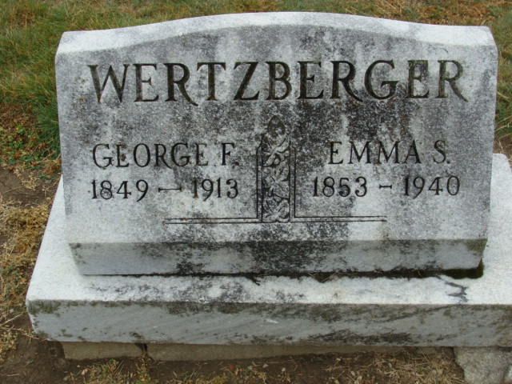
Photo by Alicia Kneuss

WERTZBERGER

Decatur, June 1 – Mrs. Emma Wertzberger, 87, native of this city, died this morning at the home of her son, George Wertzberger of Hammond.
Surviving are four sons, Al, George, Lawrence and Robert, all of Hammond and one daughter, Mrs. C. E. Baughman of this city.
Funeral services will probably be held Monday at Hammond with burial here.

Fort Wayne Journal-Gazette (IN); June 2, 1940

