Joan (Riley) Workinger Johnson
December 24, 1933 – December 31, 2014

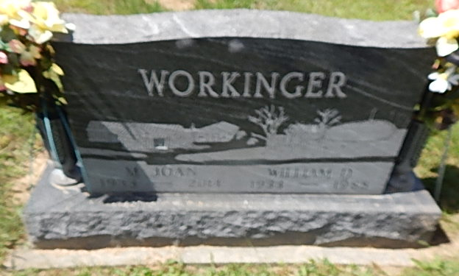
Photo by Alicia Kneuss

Joan Workinger-Johnson, 81, of Decatur, IN, passed away on Wednesday, December 31, 2014 at Lutheran Hospital in Fort Wayne. She was born on December 24, 1933 to the late Reed and Esther (Mauller) Riley. She was a 1951 graduate of Pleasant Mills High School and married her high school sweetheart, Bill Workinger on December 30, 1951; he passed away on February 22, 1988.
Bill and Joan bought a farm on Piqua Road with hard work and sacrifice, where they went on to raise their five children. Bill and Joan were engaged in farming and were the owners of Workinger Trucking. Joan retired from driving a school bus for Adams Central Community School after 32 years. She could also be seen at an Adams Central sporting event at any or all the days of the week watching her grandchildren.
She was a member of the Pleasant Mills United Methodist Church, where she held many offices, was a member of the U.M.W., and served as the church pianist. She was also an active member of the former Eastern Star, where she also held many offices including Worthy Matron. On October 4, 1997 she married John Johnson, he survives.
Joan is also survived by her 5 children Sharon Fisher, Janet (Mark) Andrews, Dan (Lori) Workinger, Lori (Ked) Snyder, and Micki (John) Schultz; 15 grandchildren Myron Haines, DJ (Kristy) Haines, Stacey (Eric) Smith, Scott (Liz) Fisher, Stephanie Wable, Sandy (Doug) Beckner, Mandy (Chad) Baker, Abby (Mark) Manley, John (MaryAnne) Workinger, Joel (Megan) Workinger, Ethan (Emily) Snyder, Travis Snyder (fiancee Alex), Will Schultz (girlfriend Ali), Jenny Schultz, and Drew Schultz; great grandchildren RJ & Ian Smith, Livvy, Grace, Katie, & David Fisher, Nick, Ben, & Johnny Beckner, Brock, Cole & Alli Baker, Mason & Max Manley, Kennedy & Brynley Haines, Cain & Zeke Workinger, and William Workinger. Also with her marriage to John she gained 5 more children Deb (Randy) Landis, Jack, Don, Jim, and Randy Johnson; 5 grandchildren Nathan (Lindsey) Landis, Matt (D'Erin) Landis, Missy (Andy) Henry, Jon Johnson (fiancee Meghan), and Megan Johnson; 3 great grandchildren Kinley Landis, Ezra & Trace Henry. She was preceded in death by 2 brothers Wayne and Bob Riley, 2 sisters Neva Noll and Vivian Tricker, and 2 sons-in-law Dave Fisher and DeWayne Haines.
Visitation will be from 2:00 - 8:00 p.m. on Saturday, January 3, 2015 at Haggard-Sefton & Hirschy Funeral Home. Funeral Service will be held at 1:00 p.m. on Sunday, January 4, 2015 also at the funeral home with calling 1 hour prior to the service from 12:00 - 1:00 p.m. Officiating will be Pastor Ernie Suman and burial will take place in Decatur Cemetery.
Memorials may be made to Pleasant Mills U.M.C. or Shriners Hospitals for Children.

Haggard-Sefton & Hirschy Funeral Home online obit (accessed 6/2/2017)

