Harry G. Young
September 3, 1889 – March 4, 1968

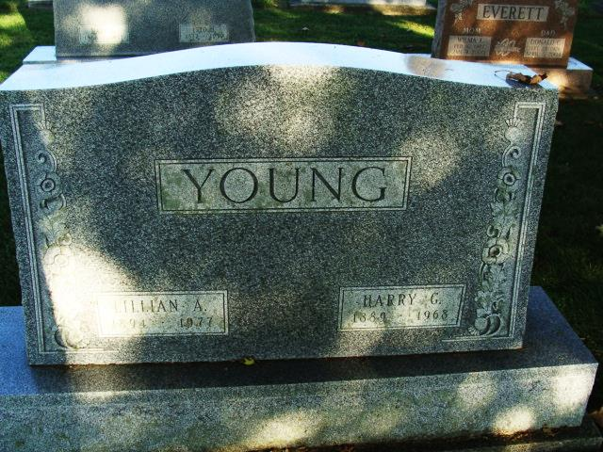
Photo by Alicia Kneuss

Dated March 4, 1968
Harry Young dies after long illness
Harry G. Young, 78, retired superintendent of the Decatur Casting Co. plant, died at 10:30 p.m. Monday at his home, 915 North Fifth street. He had been in failing health since last June.
Mr. Young came to Decatur in 1921, and served as plant superintendent here until his retirement Oct. 1, 1957. He was employed at the Hamilton, O., foundry for 18 years before being transferred to Decatur.
He was born in Hamilton, O., Sept. 3, 1889, a son of John W. and Elizabeth F. Grey-Young, and was married to Lillian Walther July 18, 1912.
Mr. Young was a member of the First Christian church in Hamilton, O.
Surviving are his wife; one daughter, Mrs. Dorothy Braun of Sunnymead, Calif.; three brothers, Carl, Ralph and John W. Young Jr., all of Miami, Fla.; three sisters, Mrs. Mabel Schlottermiller and Mrs. Blanch Schuster, both of Hamilton, O., and Mrs. Earl (Lillian) Klingel of Dearborn Heights, Mich.; three grandchildren and one great-grandchild. Two brothers are deceased.
Funeral services will be conducted at 1:30 p.m. Thursday at the Zwick funeral home, with Rev. Elbert A. Smith, Jr., officiating. Burial will be in the Decatur cemetery. Friends may call at the funeral home after (rest is missing)

Decatur (IN) Public Library Obit Book E, Image 22, p. 9
Transcribed by Janice Vasilovski

