2nd Lieutenant Beulah I Barkley
July 20, 1908 – July 27, 1944

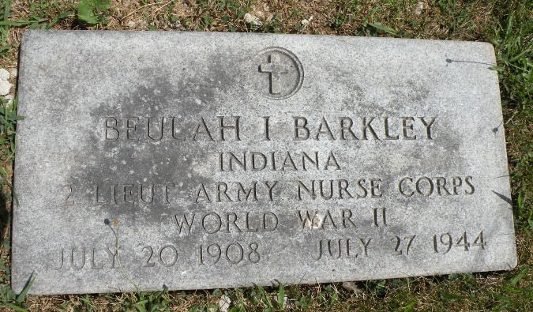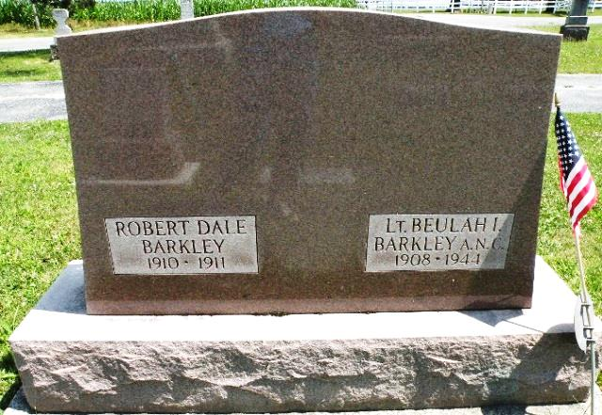
Photos by Monroeville Tombstoners

Lt. Beulah I Barkley, Army Nurse, Dies In France While In The Service Of Her County

Second Lieutenant Beulah I. Barkley, an army nurse, daughter of Mr. and Mrs. Jacob C. Barkley, 762 North Second street, died in France on July 27, the parents were notified by the war department yesterday.
Details of her death were no given, the telegram stating that a letter would follow. Lt. Barkley was on active duty with a semi-mobile hospital unit and death may have resulted from wounds received while nursing the wounded.
The parents received a letter from their daughter, who went overseas in February, dated July 23, in which she stated that she was well and was in the midst of action on the France battlefront.
The first woman from this county to die while in the service of her country, Lt. Barkley was born in Union township, Adams county, July 29, 1908. She graduated from the Monroeville high school and was a graduate nurse of the Lutheran hospital, Fort Wayne. She was a member of the east Liberty United Brethren church.
A former member of the Adams county memorial hospital staff in this city, Lt. Barkley later was associated with the Visiting Nurses League in Fort Wayne, from which place she accepted a position as school nurse in Plymouth, serving in that capacity until she enlisted in the army nurses corps in March, 1943.
She was called for active duty on June 1, 1943 and took her basic training at Fort Knox, Ky., and in January was transferred to Camp Forest, Tenn., for advanced training. She sailed for England in February as was sent to France in July, attached to the hospital unit of the nurses corp.
The word of her death came as a shock to the community.
Surviving besides the parents are three sisters, Mrs. Forrest Walton of this city, Mrs. Stephen Meyers, Fort Wayne and Mrs. Donald Brown of Indianapolis and two brothers, Ivan of Monroeville, and Lawrence Barkley of Willshire, O.
The parents moved to their residence on North Second street from Union township last fall. Mr. Barkley is a prominent retired farmer.

Decatur Daily Democrat, unknown date Contributed by Louis Wolpert

*****
ADAMS CO. NURSE DIES IN FRANCE
Lt. Beulah I. Barkley, 36, First Adams Co Girl to Give Life in War

Second Lieutenant Beulah I. Barkley, 36, an army nurse and a native of Union township, and a daughter of Mr. and Mrs. Jacob C. Barkley of Decatur, died in France on July 27, according to a message to the parents from the war department. She is the first woman from Adams County reported to have died in service.
She was well known among quite a circle of friends in and around Berne, having visited here on numerous occasions with Mrs. Adolf Ferber, the former Miss Ruth Stuckey. The two ladies were in nurses training together at the Lutheran hospital in Fort Wayne, were together on the nurses’s staff at the Adams County Memorial hospital and later were room mates in Fort Wayne where both served on the Visiting Nurse League. Mrs. Ferber is a present visiting with her parents here and is quite shocked over the death of her friend.
[snip – same information as in previous article]

Berne Witness, Adams County, IN; 9 August 1944
Contributed by Shana Neueschwander of the Berne Library Heritage Room

*****
Memorial For Nurse Killed in Service

Memorial services for Lt. Beulah Barkley, Decatur army nurse, who died in France while in the service of her country, will be held Sunday afternoon at 2:30 o’clock at the East Liberty United Brethren church, south of this city, on state road ???, in Allen county.
Word of her death, which was stated as of July 27, was received by her parents, Mr. and Mrs. Jacob Barkley of South Second street, on Sunday, August 4.
Rev. Paul Garner, church pastor, will preach the sermon and eulogy. Assisting in the service will be Rev. R. R. Wilson, pastor of the First United Brethren church in this city.
Lt. Barkley was born in Decatur July 29, 1909. She attended the Monroeville high school and was a graduate nurse of the Lutheran hospital, Fort Wayne.
Since February, 1944, she was stationed in England, landing in France July 19, celebrating her 36th birthday anniversary the next day and only one week prior to her
(Turn to page 5, column 4 – not included)

Decatur Daily Democrat – unknown date Contributed by Louis Wolpert

