KIRKLAND YOUTH, LEONARD LANDIS, KILLED IN FRANCE
Twenty-Year-Old Youth Gives Life in Infantry on September 10
Pfc. Leonard E. Landis, 20, son of Mr. and Mrs. Earl Landis, residing three miles west of Monroe, was killed in action in France, on Sunday, September 10, according to a telegram delivered to the parents on Monday evening, from the war department.
The message stated, “The Secretary of War desires me to express his deep regret that your son Private First Class Leonard E. Landis was killed in action on ten September in France. Letter follows. J. A. Ulin, the Adjutant General”
Pfc. Landis had been overseas only two months, arriving in England on July 12 and had entered the army March 1943. He last letter home was written on Labor Day, the 4th and was received on the 20th. He was serving with the 80th Division of the U. S. Infantry.
The young soldier had his basic training at Camp Wolter, Texas and was on maneuvers in Tennessee, Kansas, California and Arizona, going overseas from New Jersey.
Born in Kirkland township, he would have been 21 years of age on October 11 and was a son of Earl and Bertha Fugate Landis. His entire life was spent at home assisting his father in farming. He attended Kirkland high school.
Surviving beside the parents are seven brothers and sisters: Homer in Washington township and the following at home: Harvey, Ruth, Arthur, Herman, Willard, Marie, Clifford and Cleo.
Pfc. Landis was a member of the Pleasant Dale Church of the Brethren of which Rev. Russell Weller of the local high school faculty is the pastor.

The Berne Witness, Adams County, IN; Wednesday, September 27, 1944

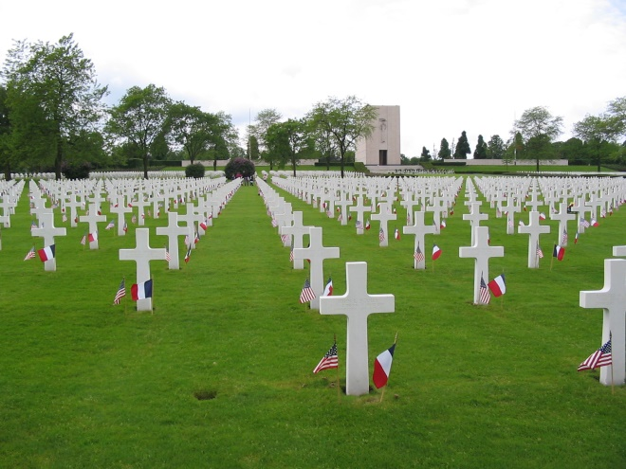
Lorraine American Cemetery & Memorial
Saint Avold, France

