S/Sgt. John Henry Schlagenhauf
October 27, 1919 – July 7, 1944
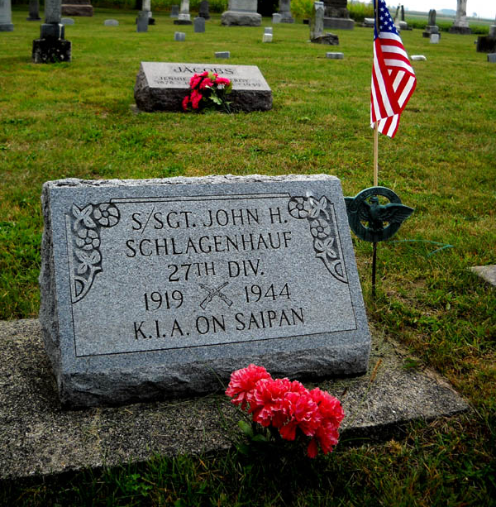
Photo by D R Buck
SCHLAGENHAUF BODY TO ARRIVE THURSDAY
Funeral Saturday For War Veteran
The body of Staff Sgt. John Henry Schlagenhauf, Linn Grove soldier killed in action against the Japanese on Saipan July 9, 1944, will arrive in Decatur Thursday night on the Erie, and will be met by a delegation from Adams Post 43, American Legion, and will then be taken to the Yager funeral home at Berne.
Funeral services for the war veteran will be held at 2 p.m. Saturday at the home of the parents, Mr. and Mrs. George Schlagenhauf, Linn Grove, and at 2:30 o'clock at the Old Salem cemetery, three miles west of Linn Grove.
The Rev. Clyde Walters will officiate and military rites will be conducted at the grave by Grover Sheets Post 111, American Legion, of Bluffton. The body will be removed from the Yager funeral home to the residence at 2:30 p.m. Friday, where friends are invited to call.
Sgt. Schlagenhauf entered the army Sept. 22, 1941, leaving with a Wells county contingent, and was sent to Hawaii in March of 1942 with an anti-tank company of the 105th infantry.
Surviving in addition to the parents are three brothers, Homer, Robert and Vaughn, and one sister, Miss Mary Schlagenhauf.
Decatur Daily Democrat, Adams County, Indiana; June 16, 1948
Contributed by Karin King

