Thomas Jefferson Baughman
July 15, 1844 – October 25, 1905
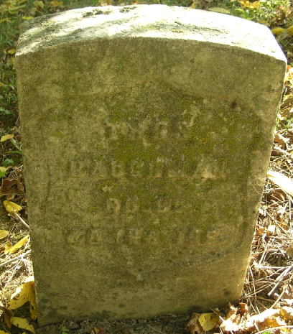
Thomas Baughman was born in this county on July 15, 1844. At the beginning of the Civil War, he enlisted in the 40th Indiana Infantry and was a member of Company C.
After the war ended, he returned to this county and was married to Nancy J. Sutton of Bluff Point, who with six children survive him.
The funeral services were held at the Bluff Point Church at ten o'clock Thursday morning. Interment was made in the Bluff Point Cemetery.
The Portland Sun, Jay County, IN; no date
*****
Thomas Baughman died Wednesday morning at 2 o’clock at his late home one and one-half miles northeast of Bluff Point. For some time past he had been in poor health and Monday night his condition became suddenly worse and continued so until death relived him, he dying in convulsions. Mr. Baughman was erecting a new residence on his farm. The work was almost completed and the family expected to move into the dwelling this week. He was able to be about his work Monday, doing some work on the inside of the house on that day.
Mr. Baughman was a member of Company C, 40th Indiana Infantry. A wife and six children survive: Charles E. Baughman of Decatur, Addie F. married and living in Ft. Wayne, James A. Baughman of Redkey, Samuel J. Charles R. and Joseph C., who are at home. One brother and three sisters are also living – Daniel Baughman and Mrs. Vine Wooley of Cincinnati, Mrs. Matilda Prosser of Florida and Mrs. Mary Rittenhouse of Indianapolis.
The funeral services were held Thursday morning at 10 o’clock from the church at Bluff Point, Rev. Mrs. Sanders officiating.
Portland Commercial Review (IN); November 2, 1905
Both contributed by Jim Cox

