Clifford H. Bisel
July 11, 1879 – October 22, 1950
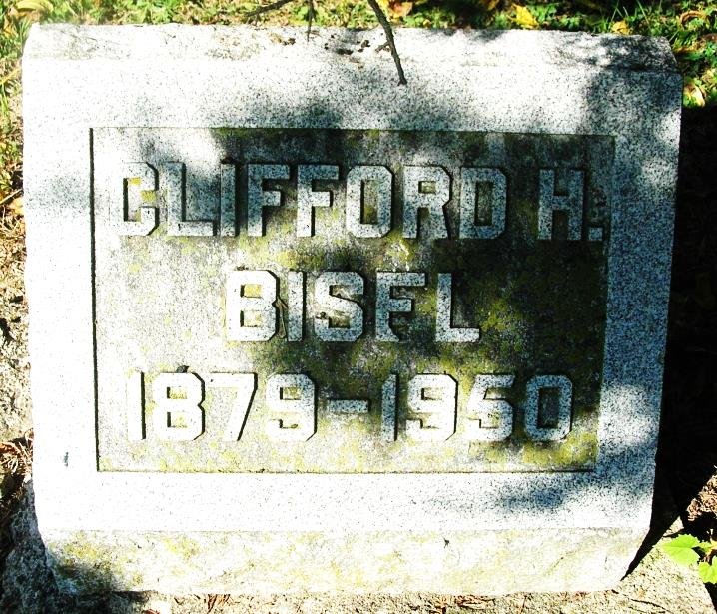

Clifford H. Bisel, 71, well-known farmer residing 3 miles northeast of Portland, died Sunday morning at 10’clock at the Ball Hospital in Muncie. Mr. Bisel had been in failing health for the past two years.
Born in Pike Township, July 11, 1879, he was the son of Abraham and Naomi Bisel.
Surviving are two sons, Russell and Robert Bisel and two daughters, Mrs. Gladys Goad and Mrs. Leona Purvis and 6 grandchildren, all of Muncie and two sisters, Mrs. W. W. Lacey of Muncie and Mrs. Arthur Alexander of Portland.
The body was removed to the Baird Funeral Home where friends may call. Funeral services will be held Tuesday at 1:30 pm from the Baird Chapel in charge of Rev. Walter McAdams, with interment in the Bluff Point Cemetery.

The Commercial Review, Fort Wayne, IN; Monday, October 23, 1950

Contributed by Jim Cox

