Hannah Naomi (Moore) Bisel
June 11, 1857 – September 11, 1909
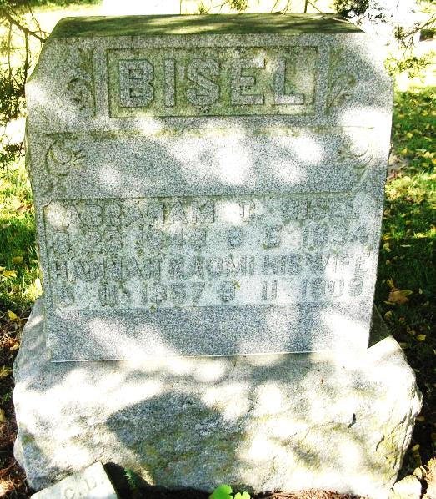

Third Stroke Proved Fatal
Death Saturday Evening Came to the Relief of Mrs. Abraham Bisel

Following a third stroke of paralysis suffered Friday evening, Mrs. Hannah Naomi Bisel, 52, wife of Abraham Bisel of three miles northwest of this city, died at her home at 6 o’clock Saturday evening. Her condition from the time of the third stroke continued critical to the end.
Mrs. Bisel was the daughter of Henry and Sarah Moore and was born at Bluff Point, June 11, 1857.
She is survived by her husband and three children, Clifford of New Castle; Effie and Elnora, both still at home. Several brothers and sisters are also left.
Short funeral services will be held at the home Tuesday morning at 11 o’clock. Public services will be held in the afternoon at 2:30 o’clock at Bluff Point, being followed by interment at the same place.

The Commercial Review, Portland, IN; September 13, 1909

Contributed by Jim Cox

