Oliver W. Boolman
March 17, 1899 – May 21, 1970
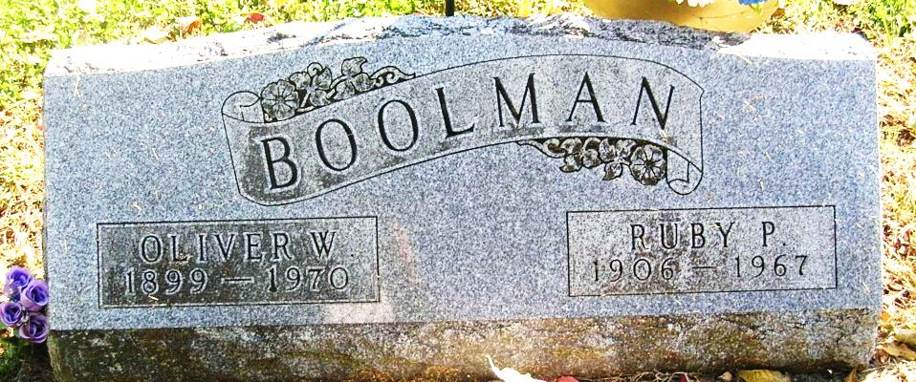

Oliver W. Boolman, 71, R.R. 2, Portland, a retired farmer, died about 10:45 Thursday morning at the Clinic Hospital in Bluffton. He had undergone surgery about two weeks ago. Boolman was a resident for many years of Belle Fountain in Noble Township.
He was born March 17, 1899 at New Weston, Ohio, the son of Harry and Ida (Dellinger) Boolman. On May 30, 1921, he was married to Ruby P Hines, who died December 4, 1967. Boolman was a veteran of World War I.
Surviving are four sons, Lloyd and Lawrence, Ridgeville; Delane and Nolan, Portland; five daughters, Mrs. Forrest (June) Goodman, R.R. 2, Portland; Mrs. Homer (Luanne) Butcher, Portland; Mrs. James (DeLoris) Evans, Zion, Ill.; Mrs. Richard (Genevive) Newton, Fort Recovery; Mrs. John (Jeanette) Newton, Dunkirk; one brother, Carl Boolman, Belle Fountain, Ohio; one sister, Mrs. Mary McKibben, Portland; 24 grandchildren and five great-grandchildren.
Funeral services are set for Saturday at 1:30 pm at the Williamson & Spencer Funeral Home with Rev. Neal Partain officiating; burial will follow in the Bluff Point Cemetery. Graveside military rites will be in charge of Robert Guy Ayers American Legion Post 211 of Portland. Friends may call at the funeral home.

The Commercial Review, Portland, IN; May 22, 1970

Contributed by Jim Cox

