Ricky W. Callahan
June 5, 1957 – May 12, 2005
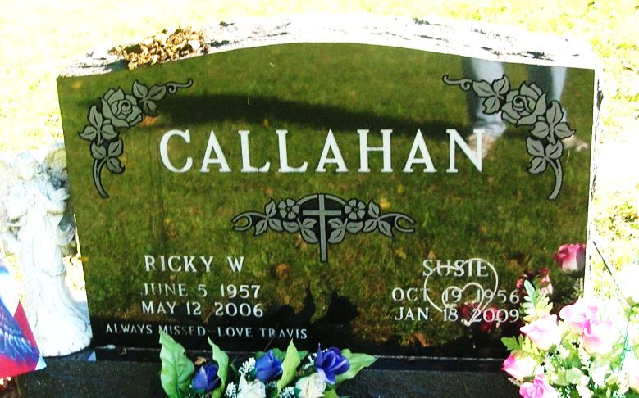
Rick W. Callahan, 48, a former resident of Pennville and current resident of Portland, died Friday at the Ball Memorial Hospital, Muncie, following an extended illness.
Born June 5, 1957 in Norton, Va., he was the son of Homer and Deanna (Terry) Callahan. He married Susan Lee on May 19, 2000. She survives.
He was employed by Gold Shield in Decatur as a supervisor for 12 years and Tyson Mexican Original in Portland as a supervisor for four years.
Surviving in addition to his wife are his mother, Deanna Butler, Vernon Hill, Va.,; a daughter Tara McIntire, Portland; a son, Travis Callahan, Pennville; two sisters, Mrs. Samuel (Linda C.) Phillips, Marion, N.C;. and Glenda F. Huss, Pennville; his grandparents, William and Eva Terry, Vernon Hill, Va.; and three grandchildren.
Services will be held at 11 am Tuesday in Portland Chapel of the Williamson and Spencer Funeral Home. Pastor Clarence Baker will officiate and burial will be in the Bluff Point Cemetery, south of Portland.
Friends may call at the funeral home on Monday from 2-7 pm. Memorials may be directed toward the Jay County Cancer Society.

Commercial Review, Portland, IN; May 15, 2005

Contributed by Jim Cox

