Joan (Anderson) Cavanaugh
September 4, 1954 – October 16, 2012
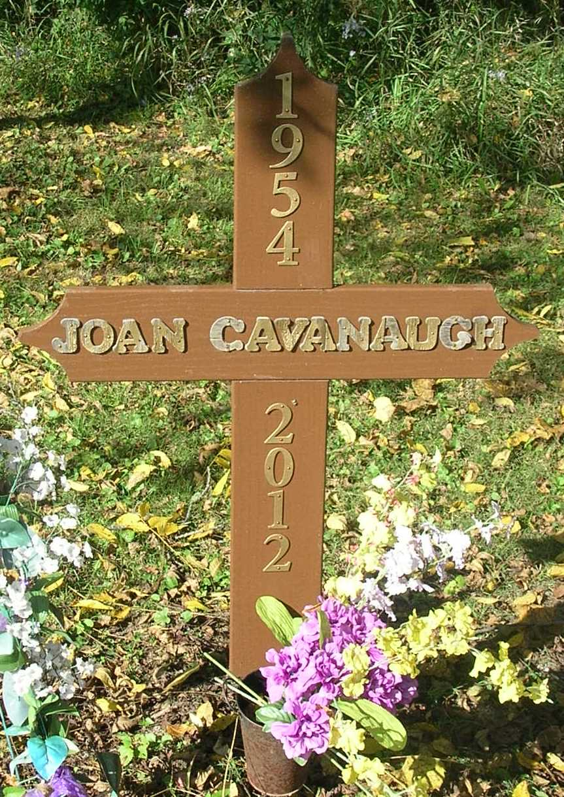

Margaret Joan Cavanaugh
September 4, 1954 ~ October 16, 2012 (age 58)

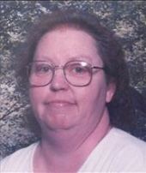
Margaret "Joan" Anderson Cavanaugh, age 58, a Bryant resident, passed away Tuesday, October 16, 2012 at Persimmon Ridge Rehabilitation Center in Portland.
She worked at Pier Mac Plastics in Portland and Bearcreek Crossing in Bryant for several years. She and her husband were foster parents to 33 children over 18 years at their Bryant home.
She was born September 4, 1954 in Portland, Indiana, the daughter of William and Grace (Ervin) Anderson. She was married August 18, 1975 to Francis "Butch" Cavanaugh who survives.
Survivors Include:
Husband- Francis "Butch" Cavanaugh, Bryant, Indiana
1 Daughter- Ashley Cavanaugh, at home
4 Brothers- Bob Anderson (wife- Gwen), Redkey, Indiana
Willie Anderson (wife-Paula), Middletown, Indiana
David Anderson (wife-Gudren), Germany
John Anderson(wife- Lisa), Dunkirk, Indiana
3 Sisters- Wanda Southworth, Bryant, Indiana
Alice Huey, Bryant, Indiana
Norma Fields, Marion, Indiana
Several nieces and nephews
Funeral services will be held at 7pm Saturday in the Williamson and Spencer Funeral home in Portland. Pastor Herb Hummel will officiate the service. Burial will be held at Bluff Point Cemetery at a later date.
Visitation will be held from 2-7pm on Saturday at the funeral home. Memorials may be directed to the family.
Williamson & Spencer Funeral Home online obit (accessed 10/30/2016)

