Albert J. Eley
March 22, 1914 – July 10, 1986
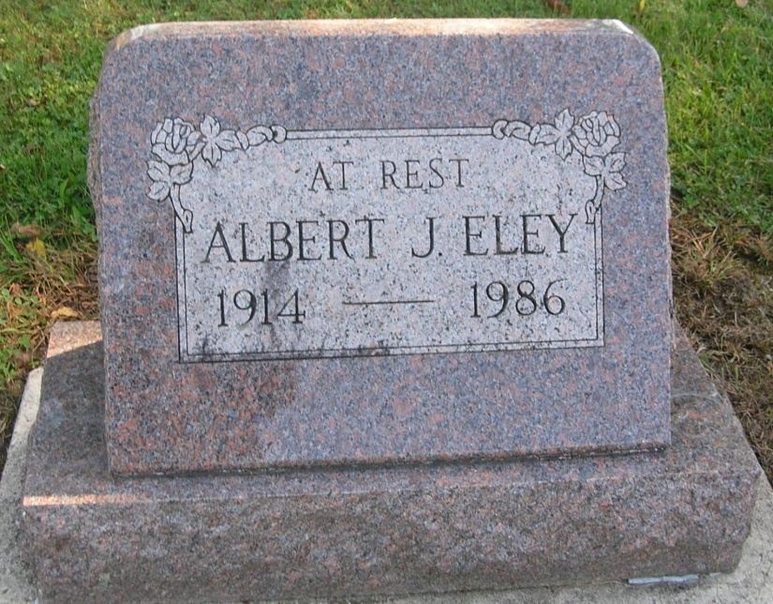

Services for Albert J. Eley, 72, R. R. 1, Portland, in Pike Township, are set for 1:30 pm Monday in the Portland Chapel of the Williamson and Spencer Funeral Home with Rev. Allen Walter officiating. Burial will be in the Bluff Point Cemetery. Eley died Thursday morning at the Jay County Hospital.
He was a farmer and member of the Bluff Point Friends Church.
Born March 22, 1914, in Pike Township, he was the son of Martin and Ida (Garringer) Eley.
Surviving are two brothers, Martin Eley, Jr., and Charles Eley, both of R.R. 1, Portland and several nieces and nephews.
Friends may call at the funeral home after 2 pm Sunday and prior to services on Monday.

Commercial Review, Portland, IN; July 11, 1986

Contributed by Jim Cox

