Ruth Geraldine (Evans) Eley
April 21, 1926 – November 30, 2017

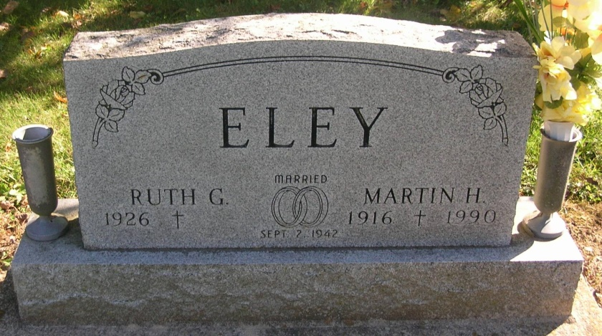

Ruth Eley, age 91, a former resident of rural Portland, passed away on Thursday, November 30, 2017 at IU Health Ball Memorial Hospital in Muncie. She was currently a resident of Miller’s Merry Manor in Dunkirk. Ruth was born on April 21, 1926, in Delaware County, Indiana, the daughter of Ralph and Clara (Michael) Evans. She was a house keeper for several people in Portland for many years. She married Martin Eley on September 2, 1942 and he passed away on April 16, 1990.
Survivors include: 3 sons: Dick Eley – rural Portland, Indiana; Tom Eley – rural Portland, Indiana; Albert Eley (wife Delores) – Dunkirk, Indiana; Several grandchildren and several great grandchildren. She was preceded in death by a son, William Eley.
Visitation will be held on Tuesday from 12 p.m. – 2 p.m. at the Williamson and Spencer Funeral Home in Portland. Funeral services will follow at 2 p.m. on Tuesday at the funeral home. Pastor Steve Arnold will officiate and burial will follow in the Bluff Point Cemetery, south of Portland.

Williamson & Spencer Funeral Home online obit
(accessed November 30, 2017)

