Donald Eckard Ervin, Sr.
May 31, 1934 – November 5, 1986
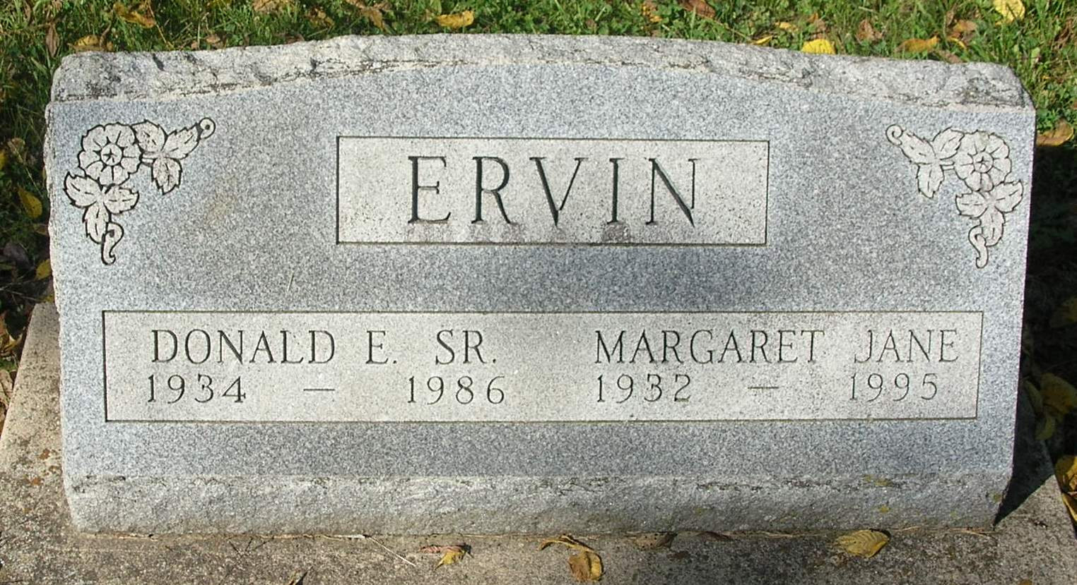
Services for Donald E. Ervin, 52, 707 N. Meridian St., Winchester, are set for 10:30 am Saturday at the Portland Chapel of the Williamson and Spencer Funeral Home with Maxon Severs officiating. Burial will be in Bluff Point Cemetery southwest of Portland. Ervin died early Wednesday morning at the Randolph County Hospital following an extended illness. He retired from Anchor Hocking of Winchester after 31 years of employment.
He was a veteran of the U.S. National Guard and was also a member of the Sympathy Club of Anchor Hocking.
Born May 31, 1934, in Terre Haute, he was the son of Eckard I. and Celia (Garringer) Ervin. He was married March 25, 1955 to Margaret Jane Landers, who survives.
Surviving besides his wife are one son, Donald F. Ervin, Jr., R.R. 1, Portland; one daughter, Mrs. Joe (Shirley) Laisure, Winchester; one brother, Eugene Ervin, Winchester; four sisters, Mrs. Helen Rigby, Athens, Mich., Mrs. Elizabeth Lacy, Muncie, Mrs. Grace Cronkhite, Portland, and Mrs. Elberta Jones, Redkey; and three grandchildren.
Friends may call at the funeral home after 3 pm Friday. The family will be present at the funeral home from 3-5 and 7-9 pm Friday.

Commercial Review, Portland, IN; November 6, 1986

Contributed by Jim Cox

