Eugene L. Ervin
July 13, 1942 – August 30, 2002
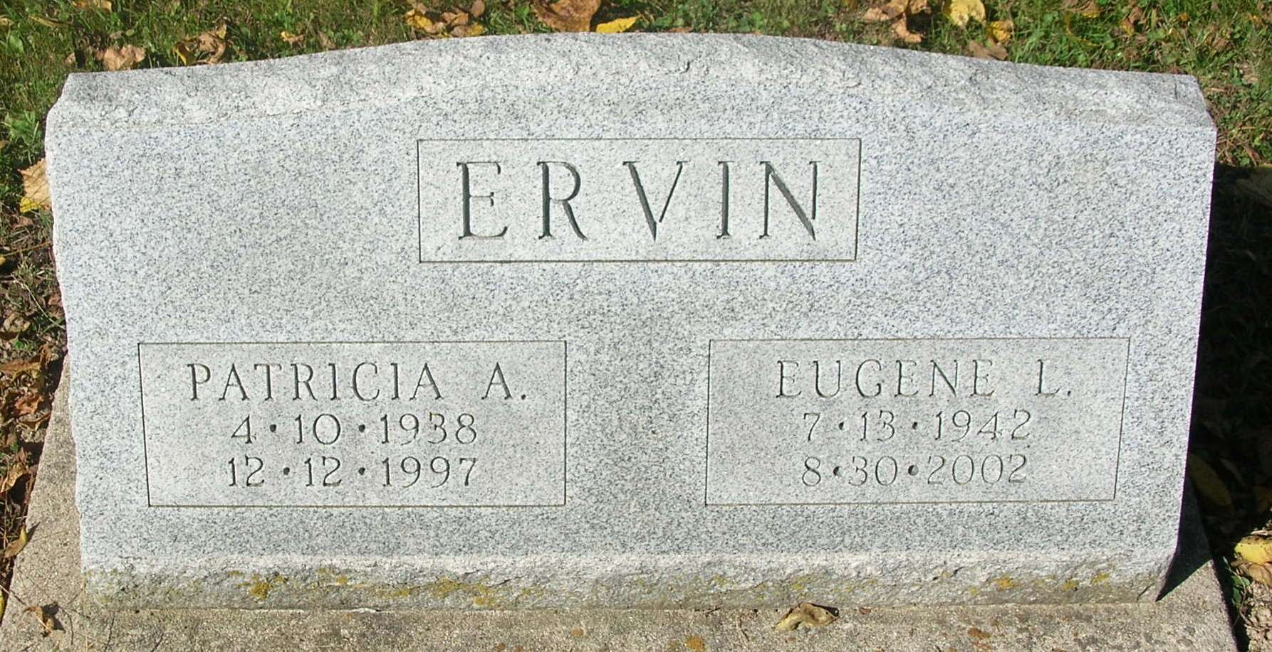
EUGENE L. ERVIN, 60, died Friday at home. Born in Winchester, he retired in 1999 from Anchor Glass Container in Winchester after 30 years. Surviving are a son, James of Winchester; a sister, Elberta Jones of Portland; five grandchildren; and his fiancee and caregiver, Hazel Pitman of Portland. Services at 11 a.m. Tuesday at Williamson & Spencer Funeral Home, Portland Chapel. Calling from 4 to 8 p.m. Monday. Bural in Bluff Point Cemetery, south of Portland. Memorials to Hospice of Darke/Mercer County.
Journal Gazette, The (Fort Wayne, IN) - Saturday, August 31, 2002

Contributed by Jane Edson

*****
Eugene L. Ervin, 60, 2225 West 600 South, Portland, died early Friday morning at his residence after a long illness.
He was born July 13, 1942 in Jay County, the son of Eckard and Celia (Garringer) Ervin.
He was a former Winchester resident and retired in 1999 from Anchor Glass Container in Winchester after 30 years of service. He was also a member of the local union 104.
He is survived by his son, James Ervin, Winchester; his sister, Elberta Jones, Portland and his fiancé and caregiver, Hazel Pitman, Portland; and five grandchildren.
Funeral services were held this morning in the Portland Chapel of Williamson & Spencer Funeral Home. Burial will take place at Bluff Point Cemetery, south of Portland.
Memorials may be directed to Hospice of Darke/Mercer County.

Commercial Review, Portland, IN; September 3, 2002

Contributed by Jim Cox

