Margaret Jane (Saunders) Ervin
December 17, 1932 – December 5, 1995
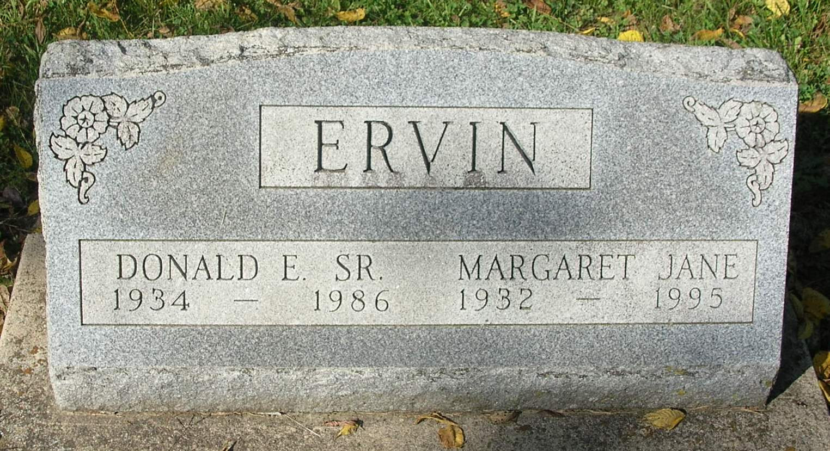

Margaret J. Ervin, 62, R.R.1, Portland, died Tuesday evening at her home.
Born December 17, 1932, in Redkey, she was the daughter of Ralph and Mable Landers [Saunders]. She was married March 25, 1955 to Donald E. Ervin Sr., who died November 5, 1986.
Surviving are her father, Ralph Saunders, Sr., R.R. 6, Portland; one son, Donald E. Ervin, Jr., R. R. 1, Portland; one daughter, Shirley M. Laisure, Portland: four stepsisters, Jennie Woods, Colorado Springs, Colorado, Mary Brenner, Montpelier, Wanda Sheltz, Bluffton and Shirley Shawver, R.R. 6, Portland; one stepbrother, Ralph Saunders Jr., Winamac; four grandchildren and three great-grandchildren.
Services are set for 1 pm Friday in the Portland Chapel of the Williamson and Spencer Funeral Home with the Rev. Hugh F. Kelly officiating. Burial will be in the Bluff Point Cemetery, south of Portland. Friends may call at the funeral home from 2 to 8 pm Thursday.

Commercial Review, Portland, IN; December 6, 1995

Contributed by Jim Cox

