Lawrence William Farris
April 27, 1925 – November 9, 1993
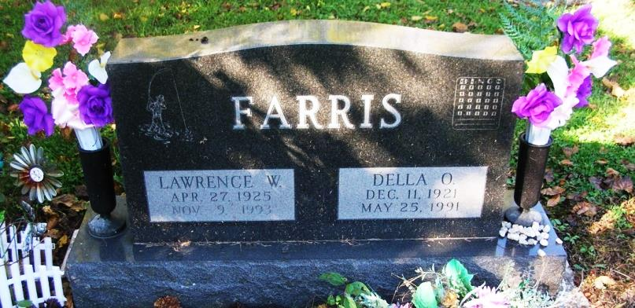
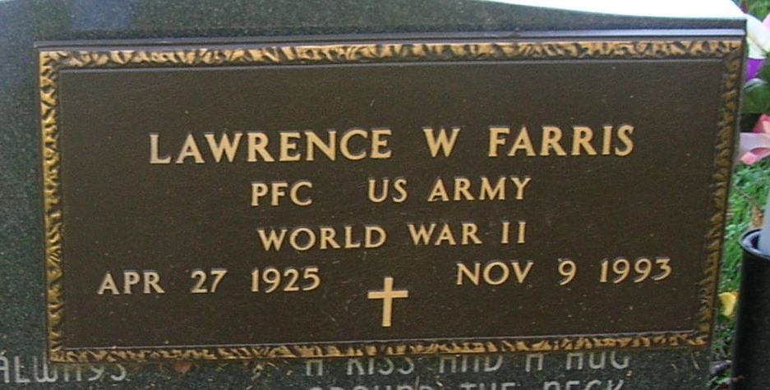
Lawrence Farris, 68, 219 S. Munson Avenue, Portland, died early Tuesday at his home. He had worked in the press room at Sheller-Globe Corp.
An Army veteran of World War II, he was a member of the American Legion Post 211 in Portland.
Born April 27, 1925, in Jay County, he was the son of Hiles and Shirley (Houtz) Farris. He was married May 22, 1946 to Della O. Garringer, who died May 25, 1991.
Surviving are two sons, Hiles Farris Portland; one brother, Rolland Hank Farris, Portland; two sisters, Judy Banta, Geneva and Connie Oberlander, Venice, Fla.; seven grandchildren and two great-grandchildren.
Private services will be held at Baird-Freeman Funeral Home with burial to follow in Bluff Point Cemetery. There are no calling hours.
Memorials may be made to the jay County Conservation Club.

Commercial Review, Portland, IN; November 10, 1993

Contributed by Jim Cox

