Faye (Money) Garringer
August 24, 1899 – August 22, 1985
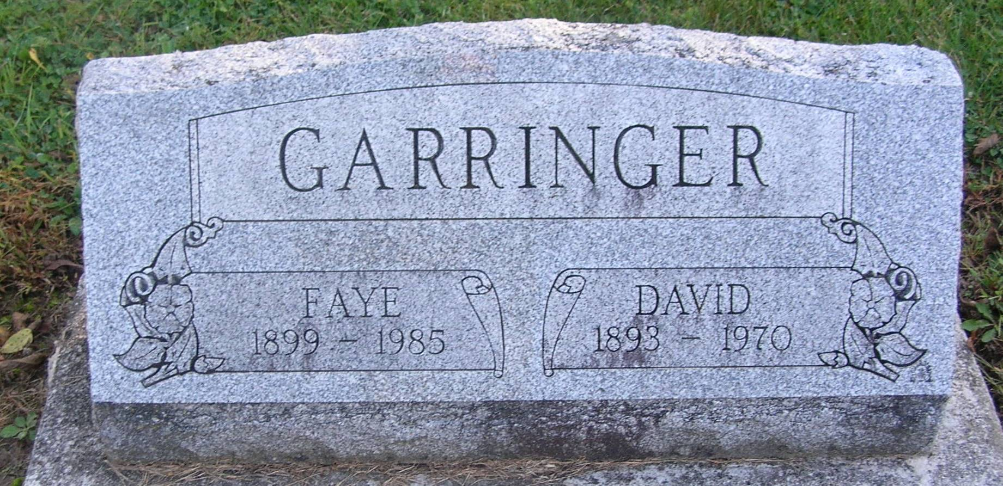

Faye Garringer, 85, 107 N. Pleasant St., Portland, died at her home Monday following a brief illness.
Born August 254, 1899, in Jay County, she was the daughter of George and Josie (Hanlin) Money. She was married November 30, 1918 to David Garringer who died December 27, 1970.
Surviving are five sons, Leo Garringer and Robert Garringer, both of Portland; David Garringer and Donald Garringer, Fort Wayne and Arthur Garringer, Indianapolis; one daughter, Betty Mann, Portland; one half-sister, Mable, Portland; one half brother, John Orville Rarick, Arcadia, Fla.; 15 grandchildren and 14 great-grandchildren.
Services are set for 2 pm Thursday at the Baird-Freeman Funeral Home with Pastor Darrell Taggart officiating. Burial will be in Bluff Point Cemetery. Friends may call at the funeral home from 2-4 and 7-9 pm Wednesday.

Commercial Review, Portland, IN; July 23, 1985

Contributed by Jim Cox

