George Alexander Garringer
April 29, 1861 – October 31, 1943
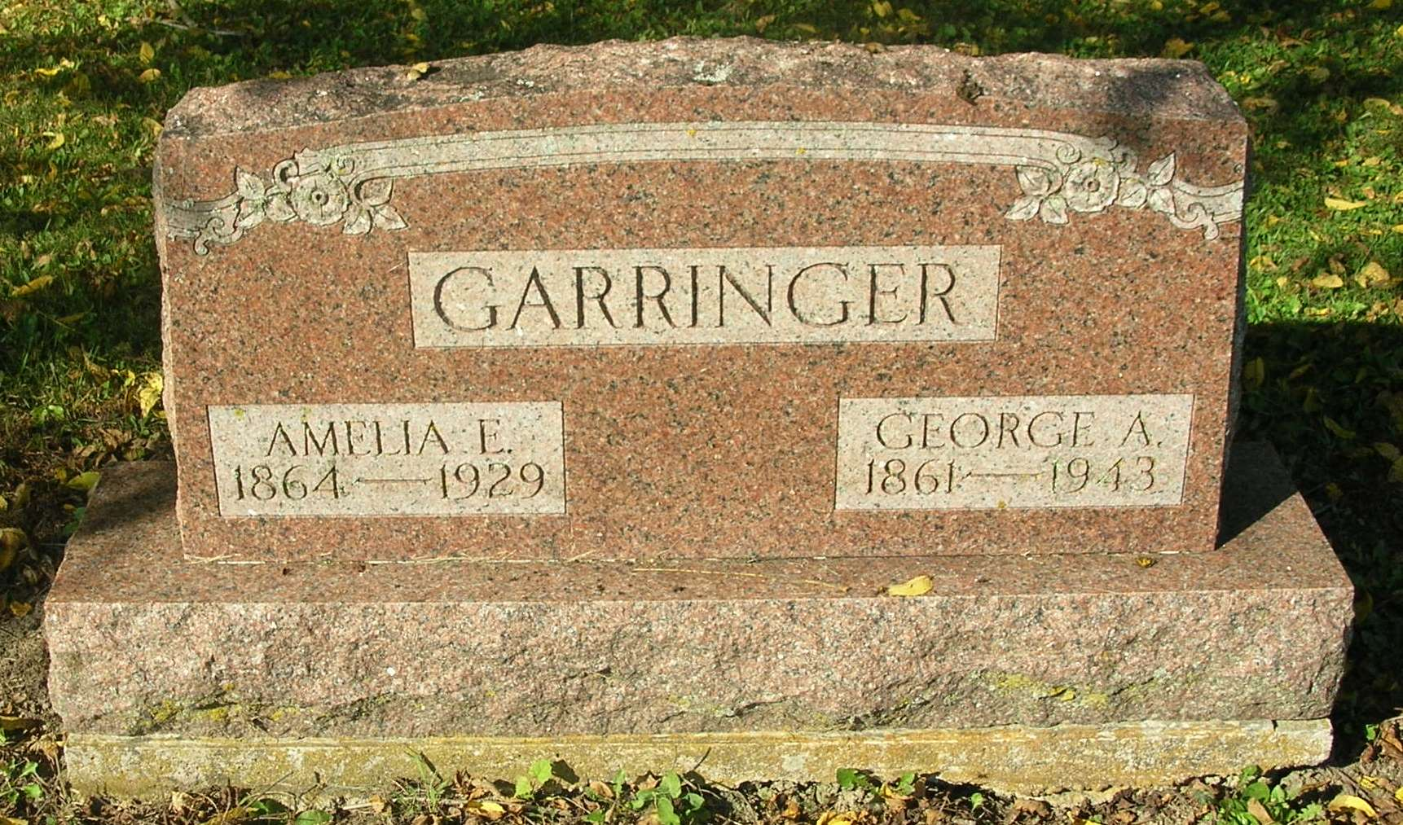
G. A. Garringer Rites Tuesday
Private Funeral Services to be Held for Well-Known Man

Private funeral services for George A. Garringer, 81, retired farmer residing south of Bluff Point, will be held from the residence Tuesday afternoon at two o’clock. Rev. H. G. Perry of Salamonia will officiate and interment will be made in the Bluff Point Cemetery.
Mr. Garringer died Sunday morning following a brief illness due to the infirmities of age. He was born on the farm in Pike Township where he spent his entire life, April 29, 1861, the son of Alexander and Elizabeth (Bonnell) Garringer. In 1885, he was married to Amelia Esther Finch, who died November 14, 1929.
He is survived by 7 children: Mrs. James Moneysmith of Noble Township; Alexander Garringer, Grover Garringer, Mrs. Tony Becktell and Mrs. Frank Hughes of Pike Township; Mrs. Harold Edmundson of Greene Township and Mrs. Paul Albertson of near Uniondale. Also 12 grandchildren and 5 great-grandchildren and a sister, Ida Garringer survives. Two sons are deceased, George and James Garringer, the latter having died in France while serving in the U.S. Military Forces during World War One.
The body was removed from the Baird Funeral Home to the residence Monday afternoon. By request of the deceased, friends are asked to omit flowers.

Commercial Review, Portland, IN; November 1, 1943

Contributed by Jim Cox

