Grace Elwina (Cook) Garringer
April 8, 1885 – January 21, 1956
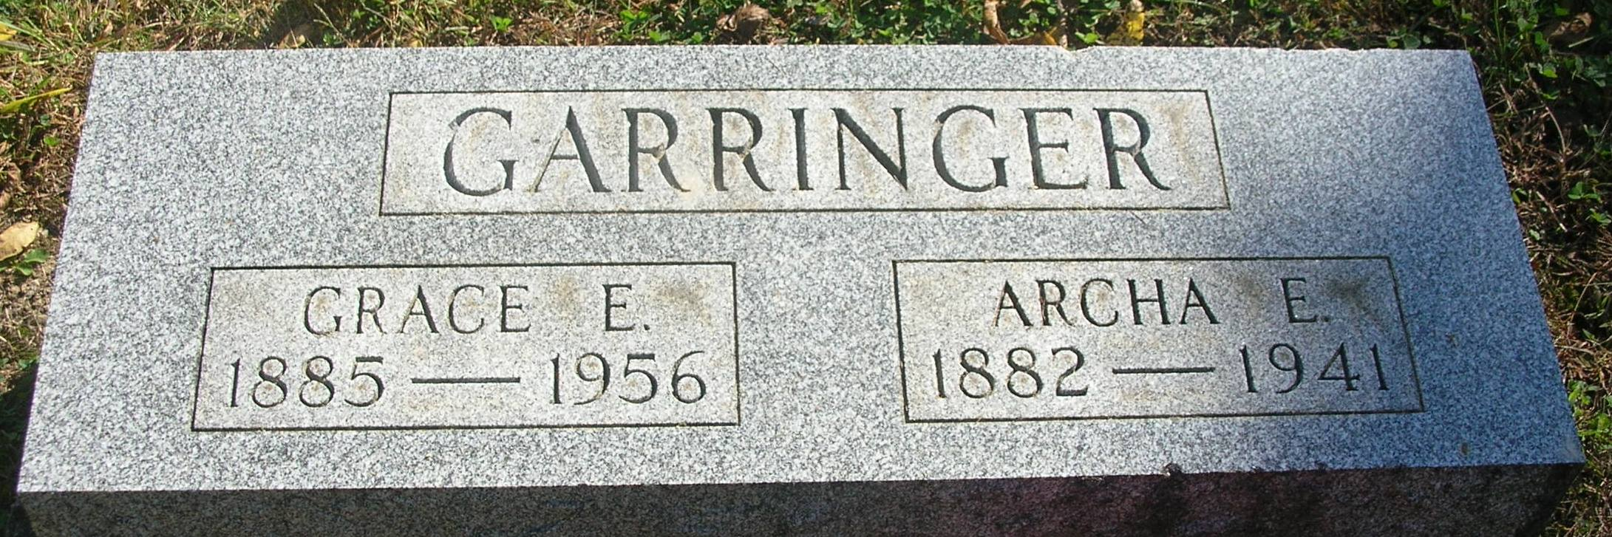
Mrs. Grace Garringer Funeral Set Tuesday

Funeral services for Mrs. Grace Garringer, 70, will be at 1:30 pm Tuesday at the Zoar Church, Rev. J. H. Nall and Rev. Robert Bisel will officiate and interment will be in the Bluff Point Cemetery. Friends may call at the Williamson Funeral Home.
Mrs. Garringer, who had been in failing health for a year, died at 11 am Saturday at the Jay County Hospital. She resided on R. R. 1, Portland. She was a native of Muncie and was born on April 8, 1885, the daughter of Abram and Jennie Cook. On October 1, 1902, she was married to Archa Garringer, who died May 6, 1941.
Surviving are the following children: Mrs. Echard Ervin of Redkey; Franklin E. Garringer of New. Mt. Pleasant; Howard Garringer of Ridgeville; Leroy Garringer of near Dunkirk; Mrs. William Spade of Oblong, Ill.; Russell M. Garringer of Redkey; Mrs. Mary Arnold of Portland; Mrs. Lawrence Farris of near Portland; Mrs. Charles Burk of near Portland, and Orla A. Garringer of Portland.
Two grandchildren, Mrs. Glen Smith of Garden City, Kansas and John Garringer of near Portland, also survive who were reared in the Garringer home. Also surviving are 334 other grandchildren; 15 great grandchildren; two brothers, Arnold Cook of Wolcottville and Paul of Florida; two sisters, Mrs. Ada Karcher of Selma and Mrs. Ralph Mullen of Muncie.
Two sons and a brother are deceased. Mrs. Garringer was a member of the Zoar Methodist Church and of the War Mothers.

Commercial Review, Portland, IN; January 23, 1956

Contributed by Jim Cox

