James H. Garringer
January 19, 1921 – April 16, 1942
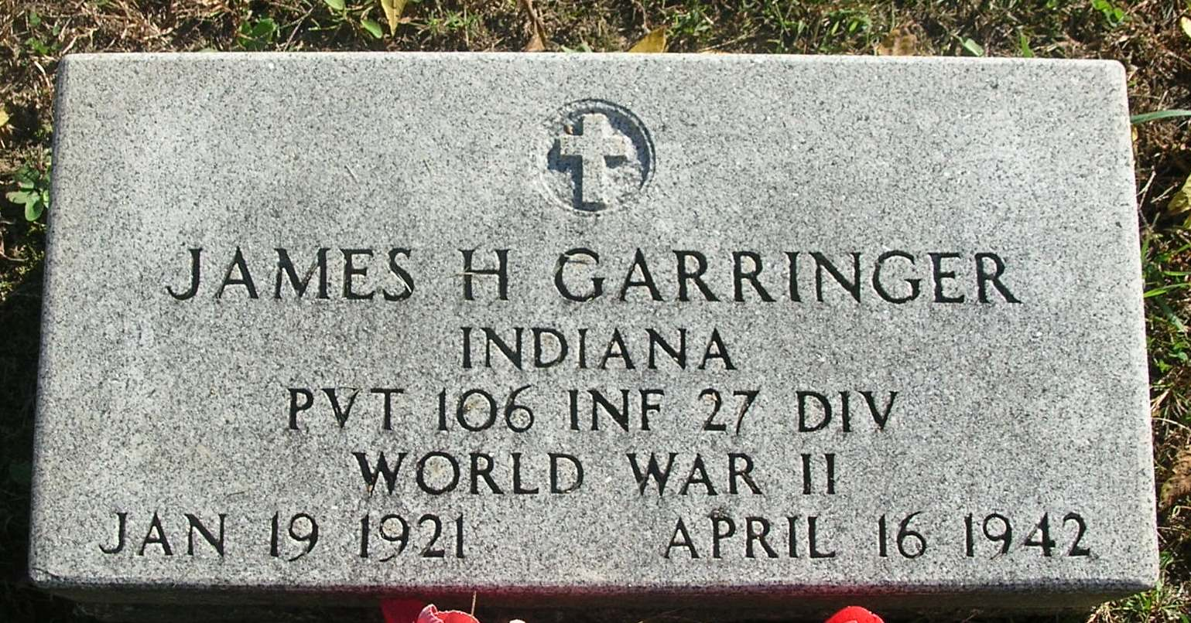
James Garringer, son of Archie and Grace Garringer of Bluff Point, was drowned in Hawaii on April 16, 1942 while attempting to rescue a buddy who got cramps while swimming in a gravel pit. He was a Private in the 105th Inf. 27th Division U. S. N. in World War II. He was born Jan 19, 1921. He is survived by his mother, Grace Cook Garringer and 5 sisters and 5 brothers. Burial in Bluff Point Cemetery.

Contributed by Kathy Strine – no source listed

Report Death of Jay County Boy
James Garringer of Bluff Point Said to Have Drowned in Hawaii

James H. Garringer, aged 22, son of Mrs. Grace Garringer of Bluff Point, was drowned in Hawaii last Friday, according to a telegram received by his mother from the War Department. Young Garringer is the second casualty from Portland during the present war as a result of drowning, the other being Richard Paul Farber. Details of the tragedy were lacking.
Garringer was inducted into the Army at Portland last September and was sent to Camp Wolters, Texas for his training. In January, he was transferred to California, later going to the Hawaiian Islands.
His exact whereabouts were undisclosed in his last letter to his mother, but it is known now that a recent letter with an obliterated postmark was marked Honolulu. It said he had arrived at his destination in Hawaii on March 13th.

Commercial Review; April 21, 1942

*****

Memorial Service for James Garringer

Memorial services for Pvt. James Garringer will be conducted Sunday morning at 9 o’clock at the Bluff Point Cemetery, six miles south of Portland.
Garringer was drowned several weeks ago in an undertow near Honolulu. His companion was rescued.
The deceased was a son of Archa and Grace (Cook) Garringer. His father preceded him in death on May 6, 1941.

Commercial Review, Portland, IN; May 29, 1942

Both contributed by Jim Cox

