William Nolan Hines
December 3, 1861 – April 26, 1933
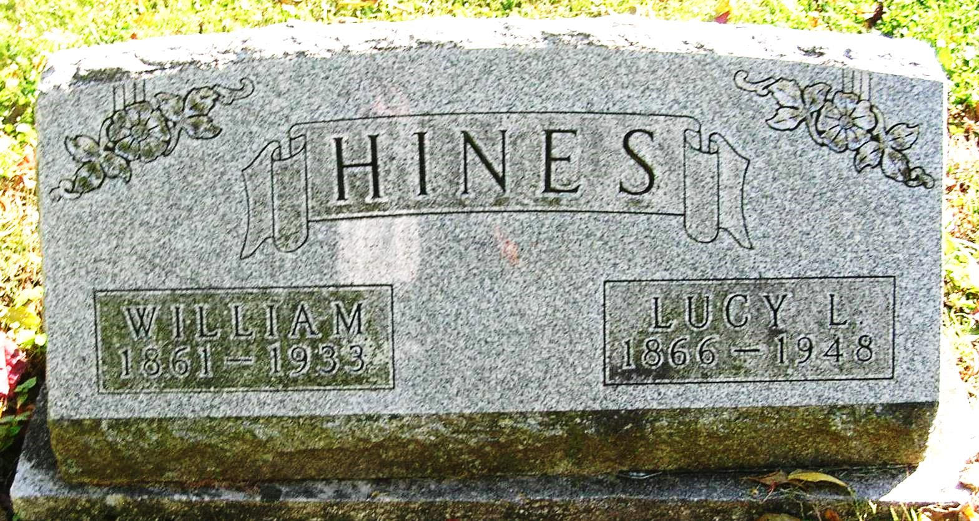

William Hines Dies Suddenly
Heart Trouble Causes Death of Aged Farmer Yesterday

William Hines, 71, died of heart trouble yesterday afternoon about 3:30 o’clock at his home about five miles southwest of Portland. He had been in ill health for the past few weeks and sitting in a chair in the living room when he suffered a light heart attack and died soon after.
The deceased was born December 3, 1861 in Fairfield County, Ohio, the son of George and Catherine (Zone) Hines. On April 12, 1890, he was married to Lucy Lucinda Garringer, who survives. They lived on a farm in Pike Township before moving to the farm they now occupy. He had been a farmer all his life.
Surviving are the following brothers and sisters: Charles Hines, J. S. Hines, Barbara, wife of James Headington of Portland; Hamilton Hines of Ridgeville; Jenny, wife of Charles Stone of Louisville, Kentucky; and Elizabeth, wife of Thomas Williams of Lawrenceville, New Jersey. Two sisters and one brother are deceased.
The surviving children are George Hines of Union City; Forrest of Columbia City; Benjamin of Winchester; Leroy of Columbia City; Rolland of Lewiston, Ohio; Lewis of near Ridgeville; Jacob of Portland; Ruth, wife of Walter Jenkinson of Ansonia, Ohio; Ruby, wife of Oliver Bowman of Fort Wayne; Goldie, wife of Lewis Arnett of Greenville, Ohio and Albert Hines, at home. One son is deceased. Four great grandchildren and 38 grandchildren also survive.
Funeral services will be held Saturday afternoon at 2 o’clock at the Bluff Point Church, Rev. George B. Addington of Winchester officiating. Interment in the Bluff Point Cemetery.

Commercial Review, Portland, IN; April 27, 1933

Contributed by Jim Cox

