Eugene Fay Jones
January 18, 1957 – October 15, 1963
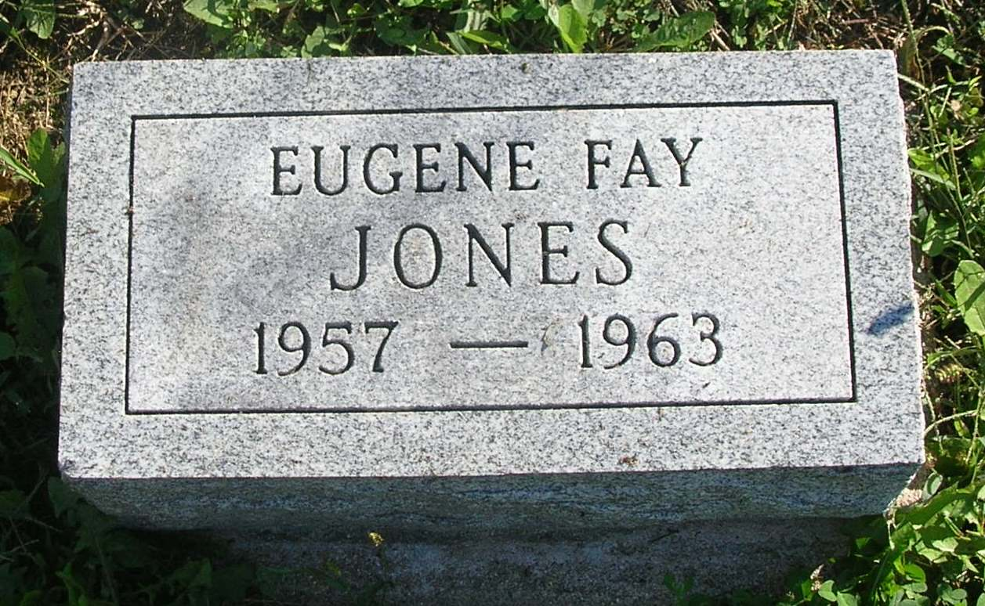

Jones Child Dies Tuesday

Eugene F. Jones, six, a resident of 804 W. Water Street, Portland, died at about 6 pm Tuesday evening at the Jay County Hospital. He had been ill for the past four weeks.
He was born in Portland January 18, 1957, a son of Russell E. and Alberta (Ervin) Jones. Besides his parents, he is survived by a twin brother, Donald Ray and another brother, William Earl Jones. Grandparents surviving are Mr. and Mrs. Sam Sheffer, and Mrs. Frank Blansett, all of Winchester. He was in the first grade.
Funeral services will be held Friday afternoon at 1:30 pm at the Williamson & Spencer Funeral Home. Rev. E. W. Boiley will officiate and burial will be in the Bluff Point Cemetery. Friends may call at the funeral home after 6 pm today.

Commercial Review, Portland, IN; Wednesday, October 16, 1963

Contributed by Jim Cox

