Clara LaVesta (Crater) McIntire
March 28, 1936 – July 8, 2009

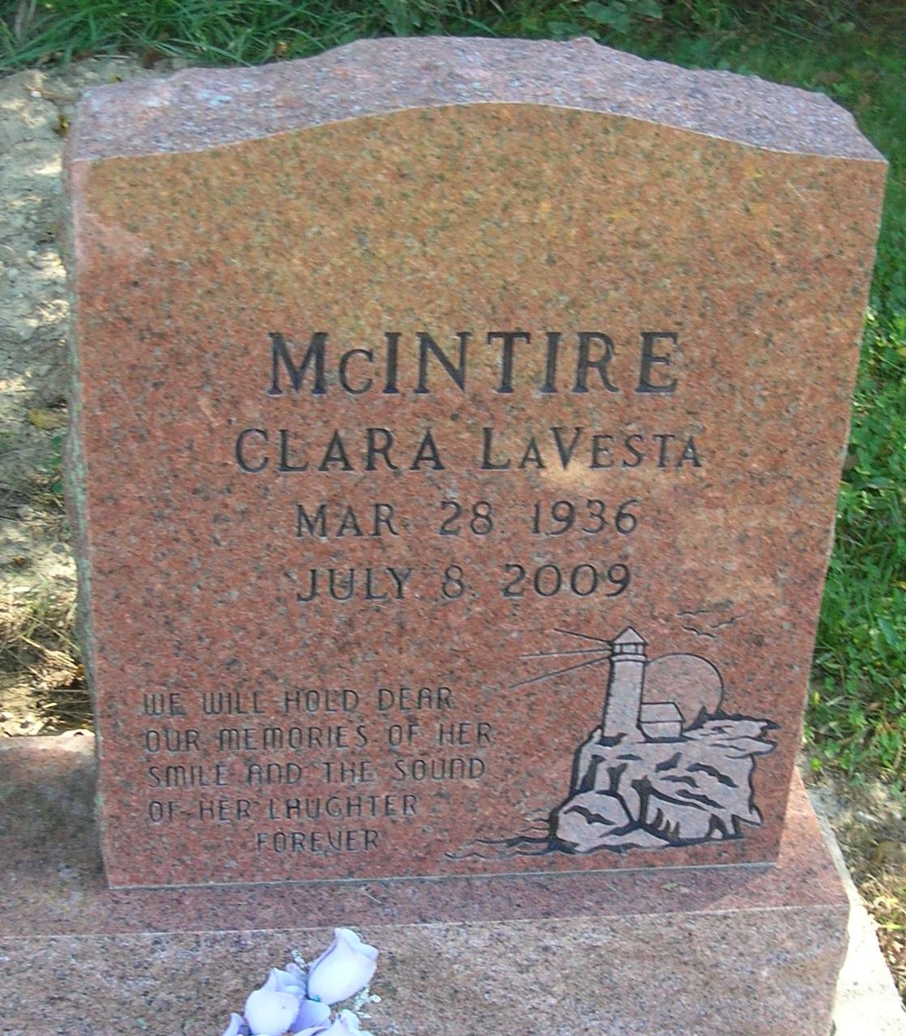

No obit found at this time

