Harry Franklin Murphy
September 26, 1957 – September 27, 1957
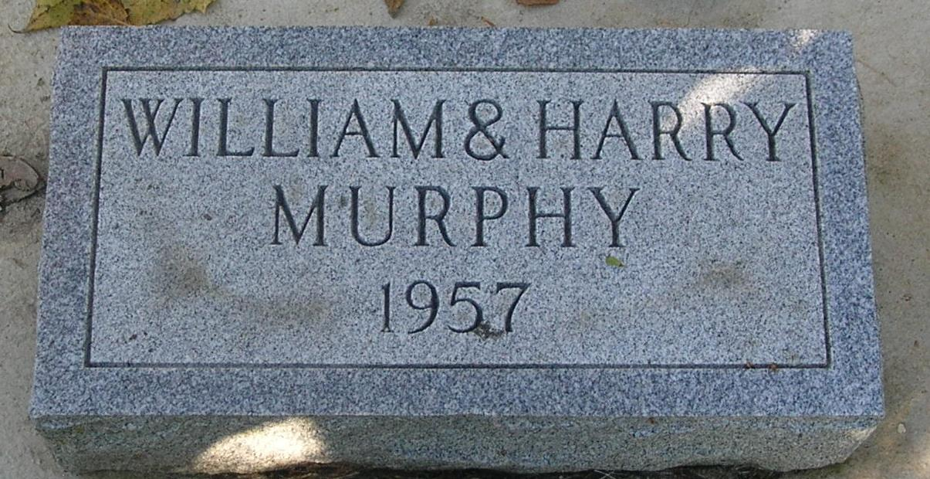
Rites for Twins Held on Saturday

Graveside services were held Saturday at Bluff Point for prematurely born twin sons of Charles and Ruth M. (Arnold) Murphy.
The twins, named William Christian and Harry Franklin Murphy, died just one day apart. They were born at the Jay County Hospital at 7 am Friday.
Survivors include two other brothers, the parents, and the grandparents, Mr. and Mrs. Lewis Murphy of Muncie; Mrs. Mary Arnold of Pike Township, Mrs. Jetta Arnold of Fort Recovery and Oscar L. Arnold of Greencastle.
The Williamson Funeral Home was in charge of arrangements.

Commercial Review, Portland, IN; Saturday, September 27, 1957

Contributed by Jim Cox

