Mandy Ray Papineau
June 6, 1979 – October 4, 1979
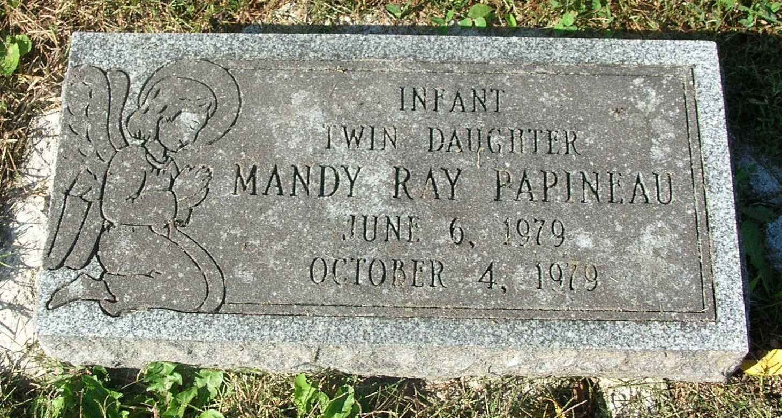
Mandy Ray Papineau, four-month-old daughter of Gary and Dedra Joan (McAbee) Papineau, 2004 West Main Street, Portland, died suddenly early today at her parent’s home.
Born June 6, 1979, in Fort Wayne, she is survived by her parents; a twin sister, Brandy Lee; grandparents, Mr. and Mrs. Bill McAbee, Portland; Mr. and Mrs. Alfred Papineau, Goshen, Mass.; great-grandparents, Mr. and Mrs. Garrett Gavin, Portland; Mr. Ralph Homan, Redkey, and L. M. Hall, Cambridge, England and great-great grandmother, Mrs. Alfred Papineau, Goshen Mass.
Graveside services will be held Saturday at 10 am at the Bluff Point Cemetery with Rev. Clarence Brock officiating. Baird-Freeman Funeral Home is in charge of arrangements.

Commercial Review, Portland, IN; October 5, 1979

Contributed by Jim Cox

