William Patterson
October 7, 1865 – February 4, 1893
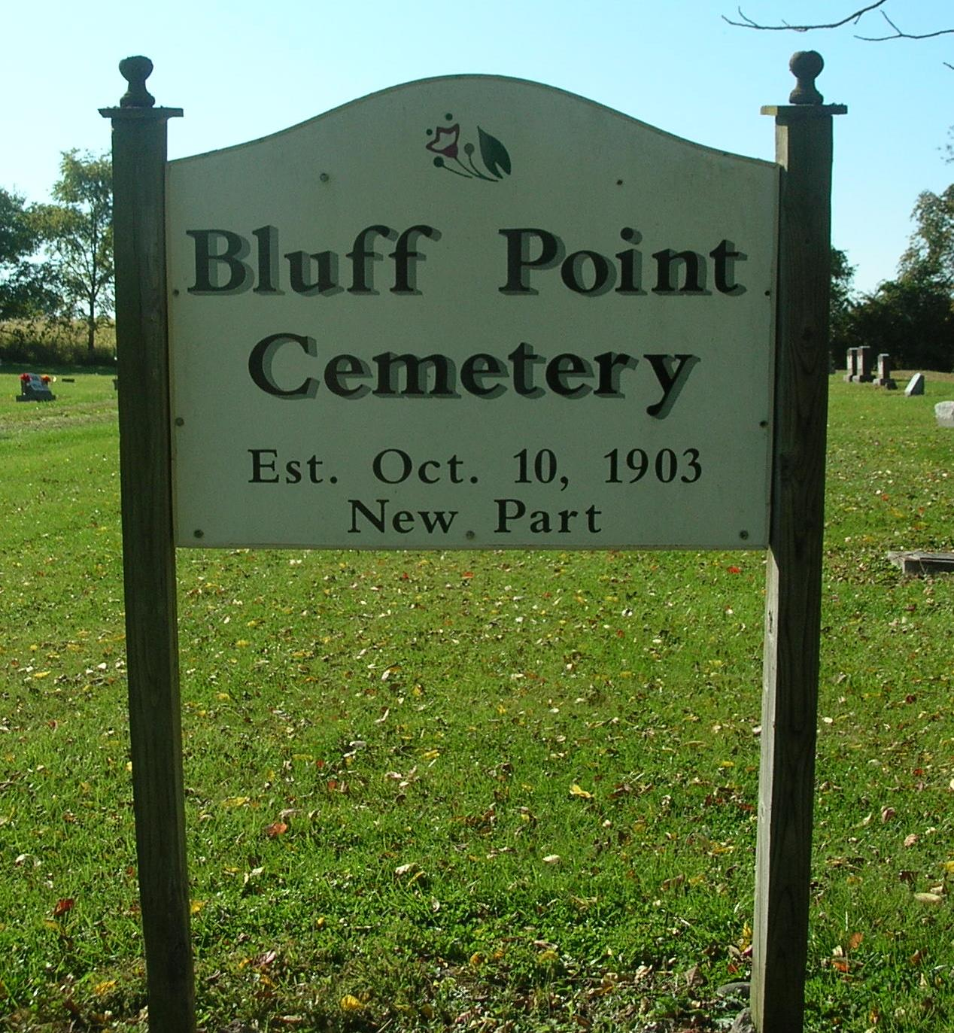

William Patterson, of Collett, died Saturday. Funeral at Zoar Monday; interment in Bluff Point Cemetery.

Portland Sun (IN); February 9, 1893

Contributed by Jim Cox

