Kenzi Dawn Penrod
September 21, 2016 – September 21, 2016
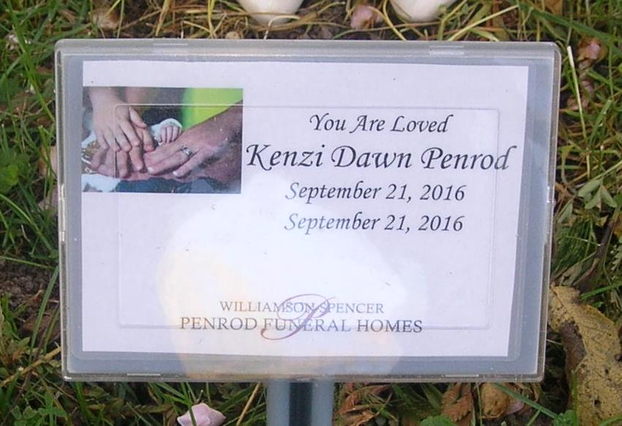

Kenzi Dawn Penrod, was stillborn on Wednesday, September 21, 2016 at Bluffton Regional Hospital in Bluffton.
She is survived by her parents: Rob and Lexie (Lee) Penrod – Portland; 2 brothers- Jacoby Penrod- Portland, IN Carsten Penrod - Portland, IN; grandparents: Todd and Joni Penrod - Portland, IN Greg and Kylea Lewis - Morehead, KY, Rick Lee - Portland, IN; great grandparents: Ron and Janet Penrod - Muncie, IN; Sherry and Terry Ellingwood - Portland, IN; Jerry and Linda Strausburg, Portland, IN; Ted and Cathy Habegger, Portland, IN; Naomi Dayton, Spring Hill, Florida. Aunts and Uncles: Jason and Kyla Penrod - Milwaukee, WI John and Darlesia Lee - Odessa, Florida
Visitation will be held on Saturday from 10 a.m. - 12 p.m at the Williamson and Spencer Funeral Home in Portland. Graveside services will follow at Bluff Point Cemetery, south of Portland.
In lieu of flowers memorials may be directed towards the Jeannie Habegger Memorial Scholarship Fund or the Melissa “Missy” Lee Memorial Scholarship Fund.

Williamson, Spencer & Penrod Funeral Home online obit (accessed September 23, 2016)

