Helen (Ervin) Rigby
July 15, 1926 – November 29, 1987
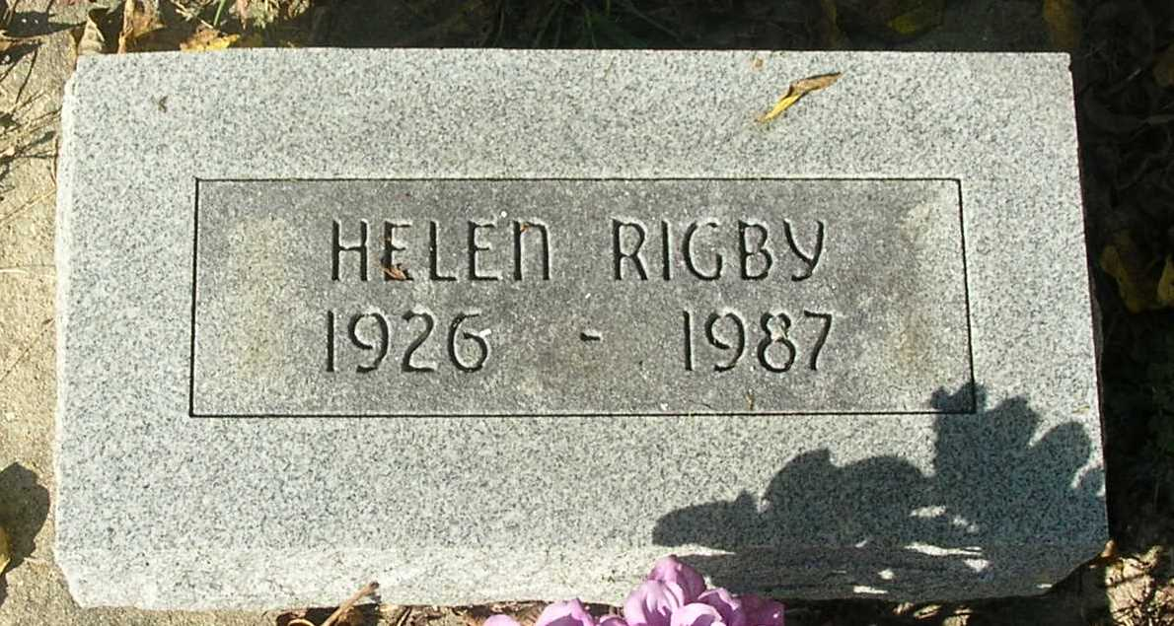

Helen Rigby, 61, Athens, Michigan, a former Jay County resident, died Sunday at the hospital following a brief illness.
She was a resident of Jay and Randolph Counties for more than 40 years and had worked at the Reeve’s Café in Winchester.
Born July 15, 1926, in Putnam County, she was the daughter of Eckard and Celia (Garringer) Ervin.
Surviving are one son, Raymond E. Baker, Lynn; two daughters, Ruth A. Straw, Redkey and Diana Fulk, Dunkirk; one brother, Eugene Ervin, Winchester; three sisters, Mildred Lacy, Muncie, Grace Anderson, Portland, and Elberta Jones, Redkey and eight grandchildren.
Services are set for 10 am Thursday in the Portland Chapel of the Williamson and Spencer Funeral Home with Marion Donathan officiating. Burial will be in the Bluff Point Cemetery south of Portland.

Commercial Review, Portland, IN; December 1, 1987

Contributed by Jim Cox

