Florian P. “Frank” Spies
March 12, 1926 – July 18, 2010
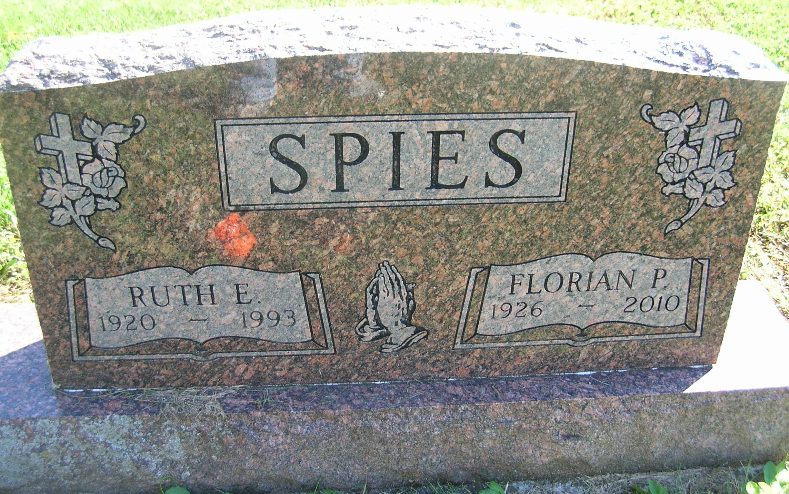

Frank Spies, 84, Anderson, former Celina, OH resident, died at the Community Hospital. He was a son to Peter and Lenoa (Wruble) Spies.
On Jun 1, 1956, he married Ruth Whitenack, who died July 6, 1993. He also married Ruth Ivey, who survives in Anderson.
Also surviving are two sons, James (Barb) Mattingly, Reno, NV, and Mike Ashby, Alexandria; three daughters, Pamela Spies, Vicki (John) Gilbert, Chesterfield, and Cindy (Kevin) Jackson, Anderson; two sisters, Dorothy Fouck, Chapman, NE, and Angline "Nell" McMann, Grand Island, NE; several grandchildren and great-grandchildren.
He worked at Snyder Concrete in Dayton for 24 years before retiring in 1987. He was a veteran of the U.S. Merchant Marines and a member of the Veterans of Foreign Wars in Celina.
Funeral services are at Williamson and Spencer Funeral Home in Portland.

Williamson and Spencer Funeral Home online obit (accessed July 19, 2010)

