Frank Sutton
– June 4, 1902
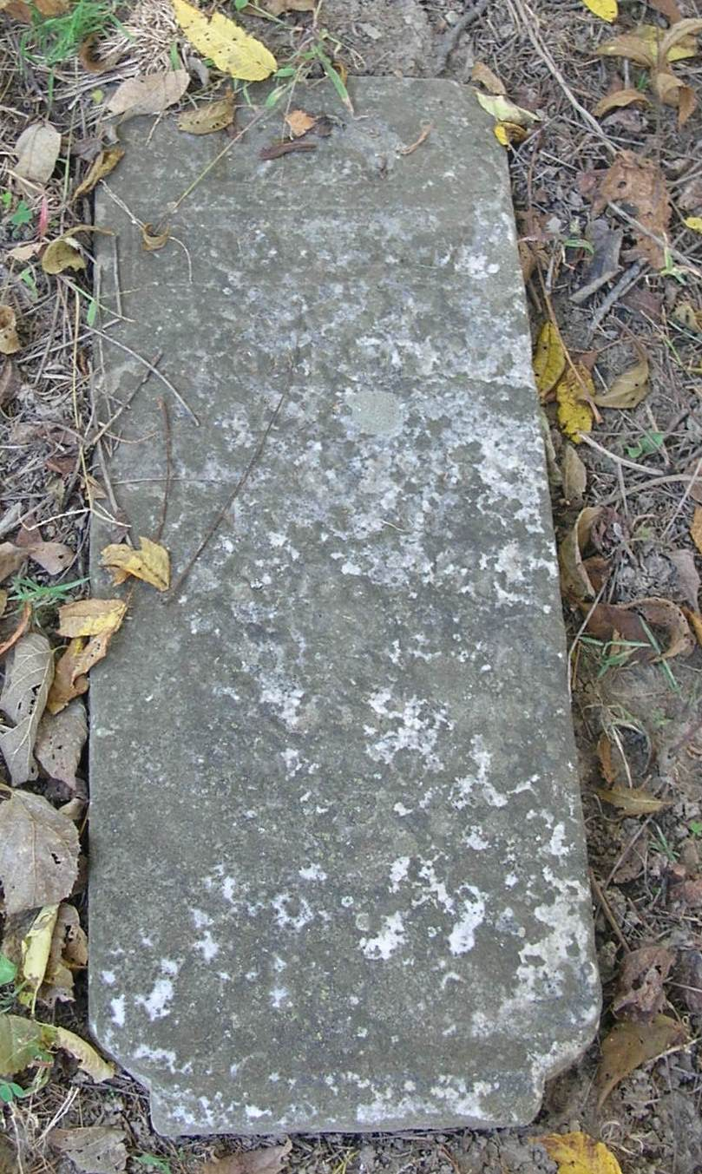
The remains of Frank Sutton were brought here on the 4:00 o’clock train Thursday from his home at Paxton, Illinois, where he died Wednesday evening at 6 o’clock.
He is a young married man with a family and is a son of Samuel Sutton of Bluff Point, at which place his remains were taken from the train.
The funeral services were held Friday morning at 10 o’clock; interment in Bluff Point Cemetery.

Portland Semi-Weekly Sun (IN); June 10, 1902

Contributed by Jim Cox

