Samuel J. Sutton
September 9, 1846 – August 22, 1923
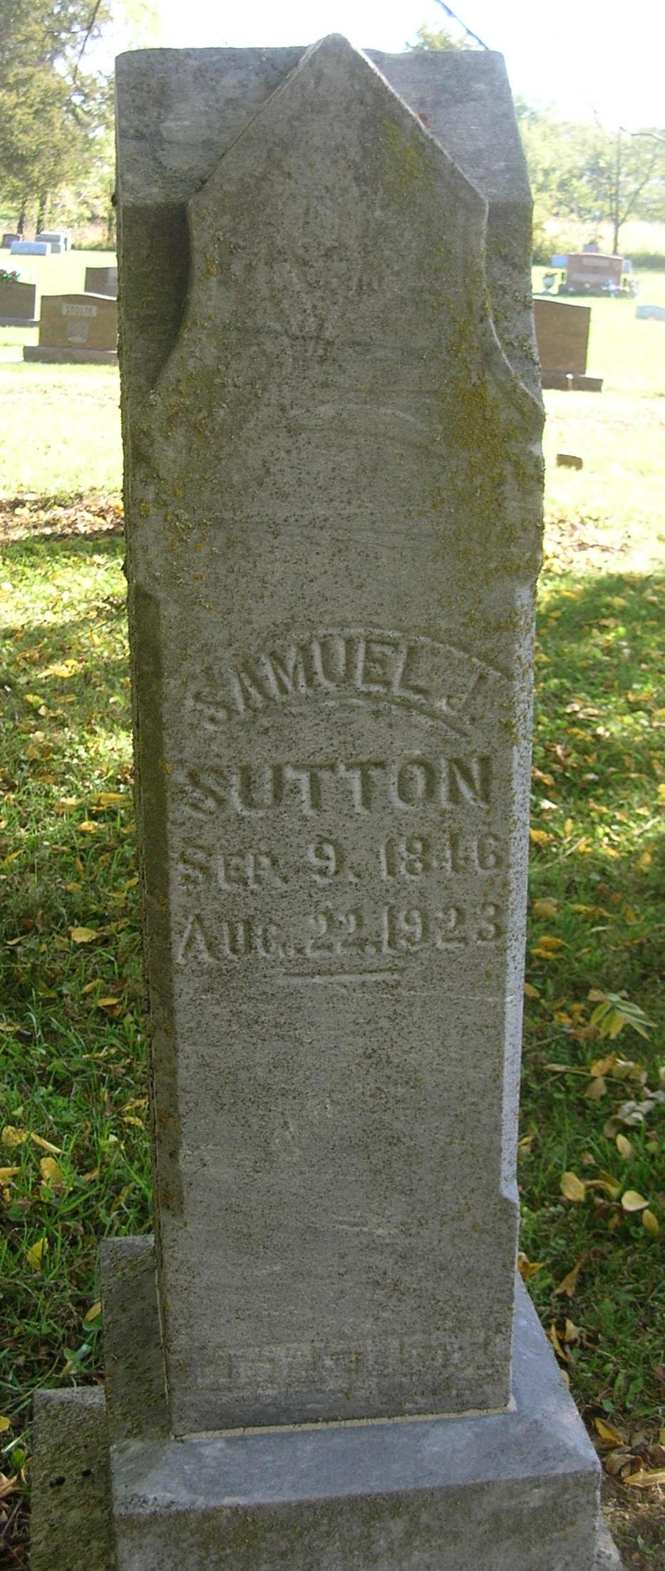

County Pioneer Passes Beyond
Samuel J. Sutton, 77, Dies from Paralysis
Spent Entire Life Here

Samuel J. Sutton, 77, died Wednesday night at 8 o’clock at his home at Bluff Point. Death was caused by paralysis. He suffered the first stroke in May of this year and the second stroke in June, and has been bedfast since.
The deceased has been a resident of Bluff Point for nearly 40 years and has spent his entire life in Jay County. Mrs. Sutton died January 15, 1900, since which time his son, Florenz, has made his home with his father.
He was born in Jay County, September 9, 1846, the son of Jacob and Fannie (Merservey) Sutton.
Surviving are the following children: Dr. William Sutton of Portland; Charles G. Sutton of Albuquerque, N.M., Florenz Sutton, who lived with his father; Alonzo Sutton of Akron, Michigan; and Ben Sutton of Bluff Point. One son is deceased.
The Rev. J. H. Nall will have charge of the funeral services which will be held at the home, the time to be announced later, when word has been received from relatives.

Commercial Review, Portland, IN; August 23, 1923

Contributed by Jim Cox

