Janet I. (Ormsby) Thatcher-McKinley
March 26, 1929 – April 25, 2000
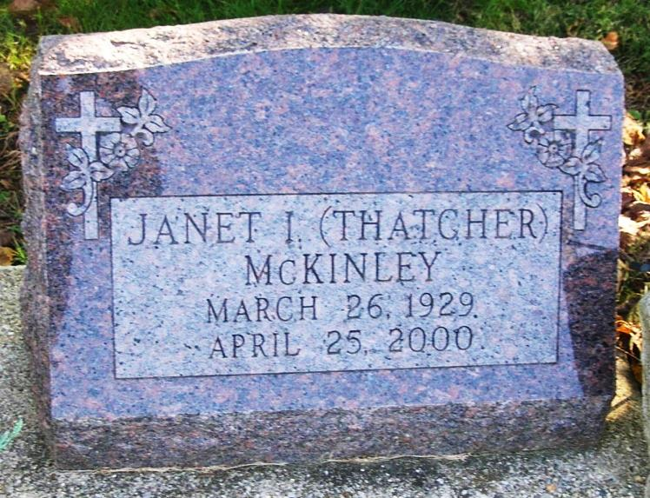
JANET THATCHER McKINLEY, 71, of Muncie, formerly of Fort Wayne and Portland, died Tuesday at Ball Memorial Hospital, Muncie. Born in Fort Wayne, she was a homemaker. Surviving are her husband, Ralph A.; a daughter, Diana; a son, Harvey; a brother, Ralph Ormsby; seven grandchildren; and five great-grandchildren. Services at 2 p.m. Saturday at Garden View Funeral Home, Muncie. Calling from 11 a.m. to 4 p.m. and 7 to 9 p.m. today, and an hour before services. Burial at Bluff Point Cemetery, Muncie. The following obituary is being republished to correct information provided to The Journal Gazette and to provide additional information.

Journal Gazette, The (Fort Wayne, IN) - Thursday, April 27, 2000
Contributed by Jane Edson

*****

Janet I. McKinley, 71, Muncie, a former resident of Portland, died Tuesday in Ball Memorial Hospital, Muncie following a brief illness.
Born in Fort Wayne, she was the daughter of Ralph and Hazel (Rarick) Ormsby. She was first married to Paul Edward Thatcher who preceded her in death and was then married in 1991 to Ralph McKinley, who survives.
She had lived in Portland and attended Portland Schools before moving to Muncie where she was a member of the Avondale Sympathy Club.
Surviving besides her husband is one daughter, Diana; one son, Harvey Thatcher; and brother, Ralph Ormsby; seven grandchildren; five great-grandchildren and several cousins in the Jay County area.
Services are set for 2 pm Saturday in Garden View Funeral Home, Muncie. Burial will be in the Bluff Point Cemetery. Friends may call at the funeral home from 11 to 4 pm and 7 to 9 pm Friday.

Commercial Review, Portland, IN; April 27, 2000
Contributed by Jim Cox

