Cynthia Louise Whitenack
December 27, 1877 – December 26, 1929
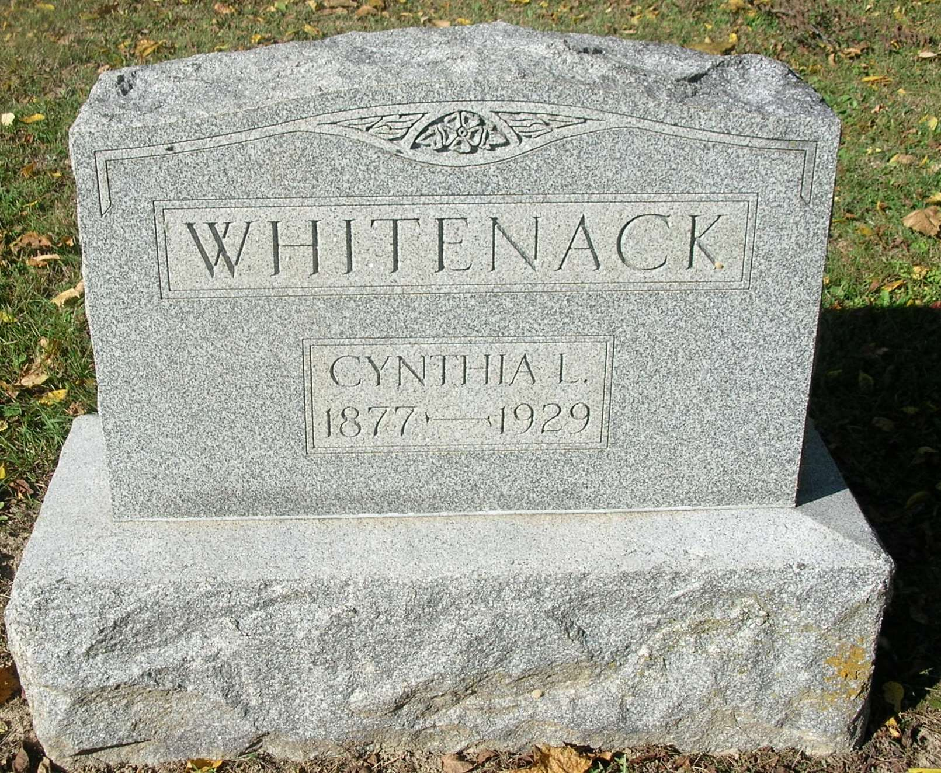

Hold Whitenack Funeral Tuesday
Services Will Be Conducted From Bluff Point Church at 10:30 A.M.

Cynthia L. Whitenack died Saturday noon at the family home, one mile southeast of Bluff Point following a lingering illness from complications.
The deceased was a daughter of Cornelius and Lucy Ann (Rathburn) Whitenack, and was born on the farm where death occurred, December 27, 1877.
She was never married and is survived by four brothers and one sister, who are: Charles Whitenack of this city; Howard Whitenack of St. Louis; James W. and Benjamin F. of Pike Township, and Mrs. Sarah Lyons of Portland. She was preceded in death by her mother, one sister and two brothers.
Funeral services will be conducted Tuesday morning at 10:30 o’clock from the Bluff Point Church, Rev. Robert Rash of Van Wert, Ohio will officiate, assisted by the pastor, Rev. George Addington. Interment will be made in the church cemetery.

Commercial Review, Portland, IN; October 28, 1929

Contributed by Jim Cox

