David Ross Whitenack
October 28, 1957 – October 30, 1957
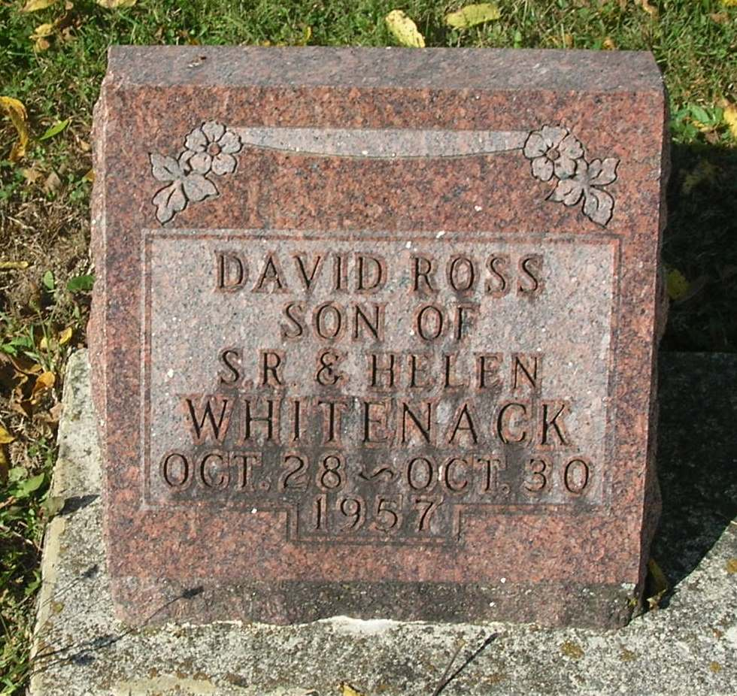

No obit found at this time

