Arnold Wilson
May 16, 1951 – May 20, 2009
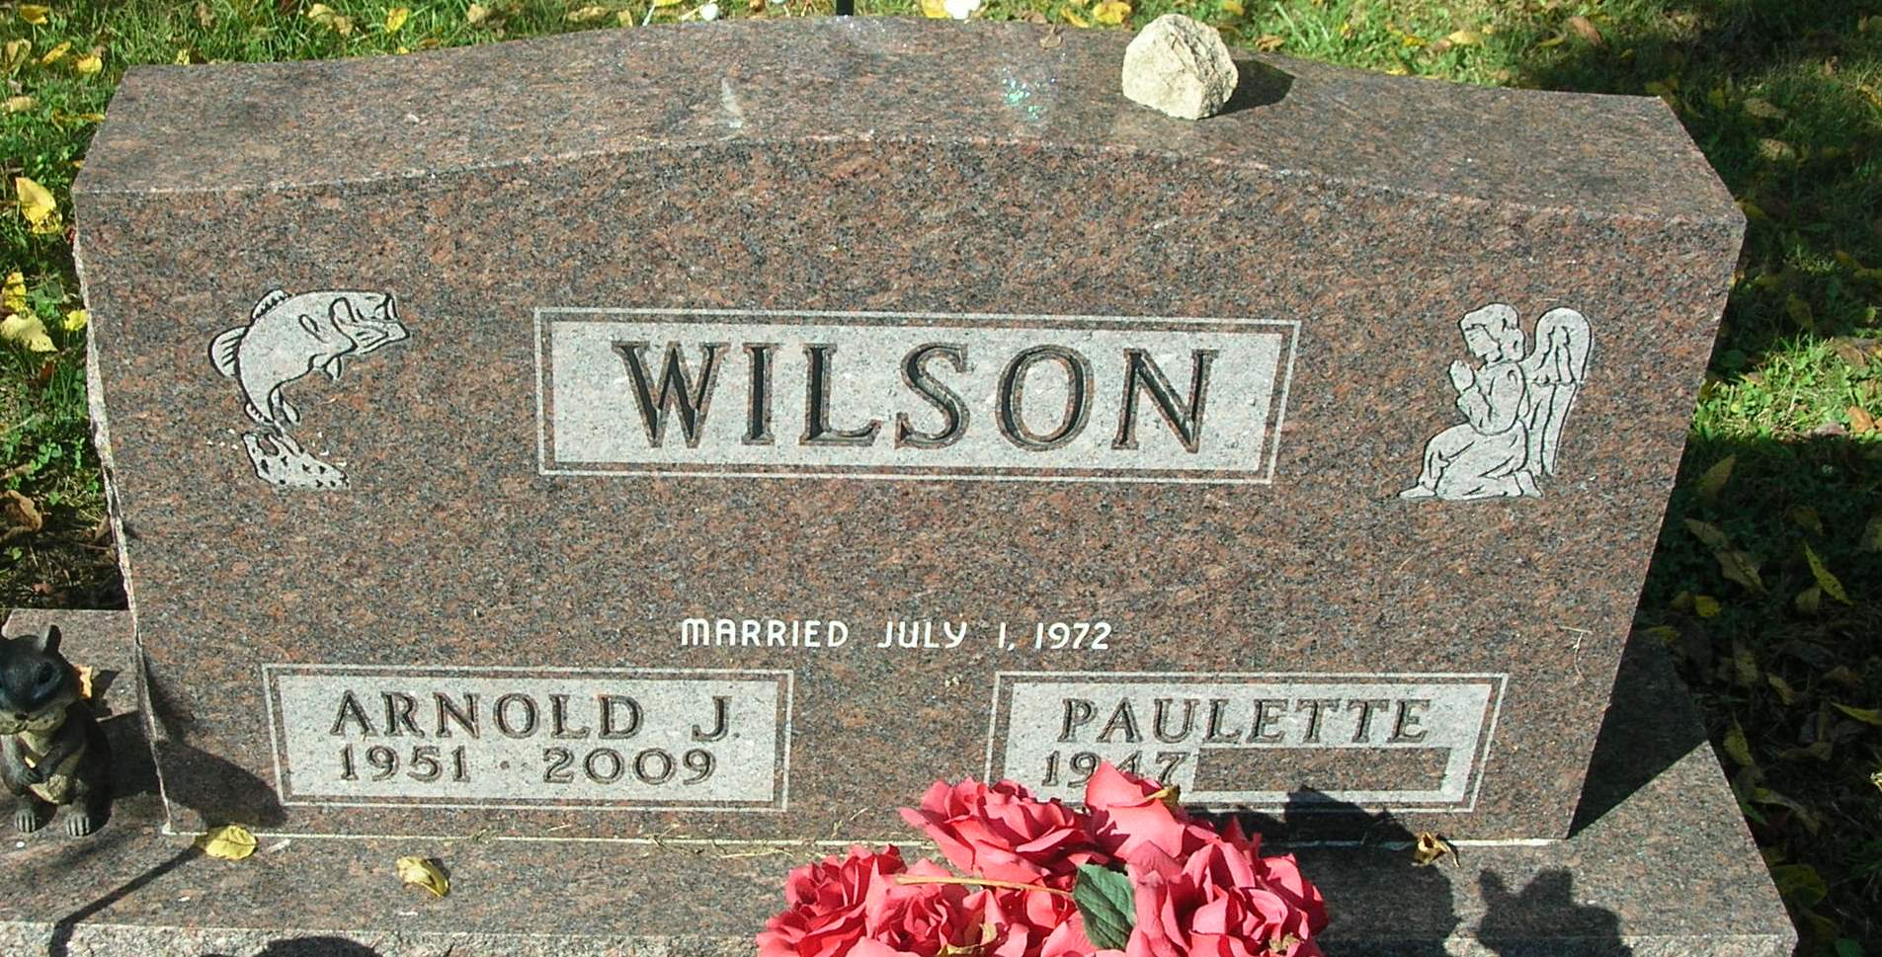

Arnold Wilson, age 58, 2738W 400 S, Portland, IN passed away early Wednesday morning at his residence. He was born May 16, 1951 in Cornersville , Kentucky the son of Arnold and Lula (Birchwell) Wilson. He was married July 1, 1972 to Paulette Copeland who survives.
He had worked for Sheller-Globe and was an U.S. Army veteran.
Surviving are his wife Paulette, mother Lula Sumner of Redkey, two sons, David Wilson of Livingston, TN. and Ray Wilson of Portland; one daughter, Tammy Irelan of Portland; four sisters, Elaine Lewis of Liberty, Betsy Craig of Hartford City, Dola Anderson of Redkey and Carrie Hambrock of Portland; and five grandchildren
Funeral services will be 2:00 P.M. Saturday in the Baird-Freeman Funeral Home with Pastor James McCowan presiding. Burial will follow in the Bluff Point Cemetery.

Baird-Freeman Funeral Home online obit (accessed May 21, 2009)

