Agnes K. Cox
November 15, 1937 – August 9, 2005

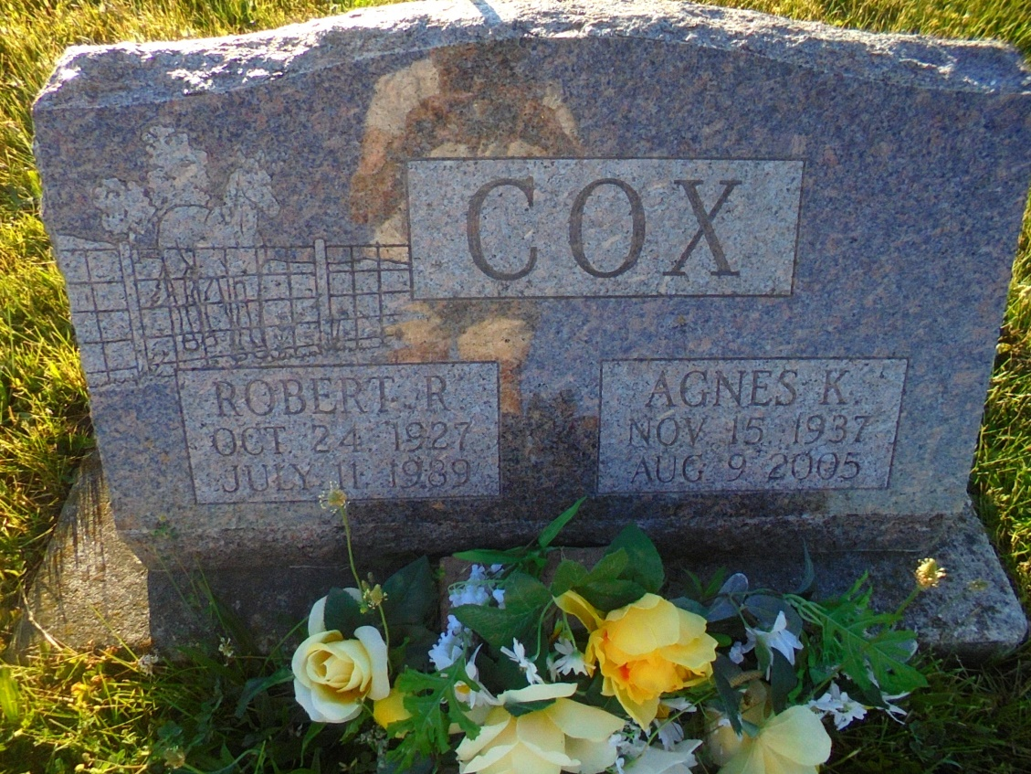
Photo by Margie Pearce

AGNES K. COX, 67, of Lincoln, Neb., died Tuesday, Aug. 9, 2005. Arrangements by Downing & Glancy Funeral Home, Geneva.

News-Sentinel, The (Fort Wayne, IN) - Friday, August 12, 2005

Contributed by Jane Edson

*****
Adams Public Library System (Decatur, IN) online obits
Publication: Decatur Daily Democrat; Date: 12 AUG 2005, p. 2A
Title: Cox, Agnes K.
Subject: Obituaries -- C -- 2000-
Abstract: Age: 67 - Lincoln, Nebraska
Died: August 9, 2005
Children: A son and a daughter
She lived in Bryant, Indiana, from 1974 - 1980.

