Harvey E. Crandall
February 12, 1908 – August 25, 1983
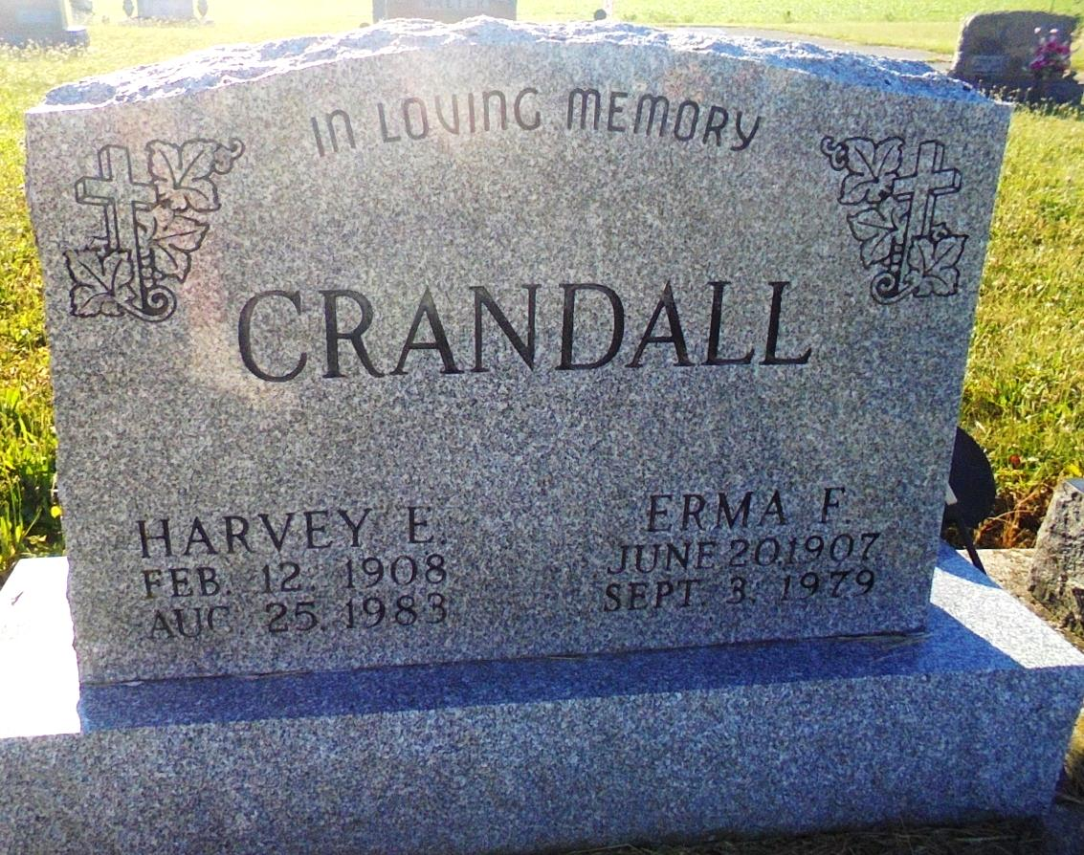
Photo by Margie Pearce

Adams Public Library System (Decatur, IN) online obits
Publication: Decatur Daily Democrat; Date: 26 AUG 1983
Title: Crandall, Harvey E.
Subject: Obituaries -- C -- 1980-1989
Abstract: Age 75
Resident of Berne, IN

