Okla L. Daugherty
1914 – January 24, 2002

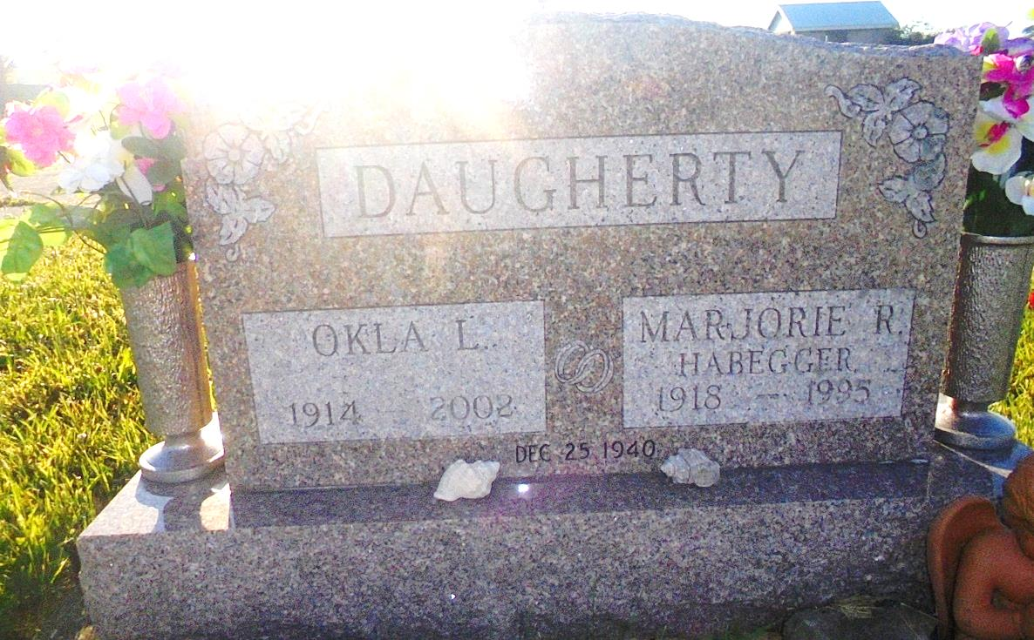
Photo by Margie Pearce

OKLA L. DAUGHERTY, 87, died Thursday at home. Born in Jay County, he was a retired dairy farmer and had been a barber in New Corydon. He was a Jackson Township trustee for eight years and a past community committeeman and county committeeman for ASCS. His wife, Marjorie R., died in 1995. Surviving are two sons, Bob and Hal of Portland; a daughter, Connie Frisch of Portland; a sister, Ruby Sipe of Berne; three grandchildren; and five great-grandchildren. Services at 10 a.m. Monday at Baird-Freeman Funeral Home, Portland. Calling from noon to 3 p.m. Sunday. Burial in Daugherty Cemetery, east of Bryant. Memorials to Trinity United Methodist Church.

Journal Gazette, The (Fort Wayne, IN) - Saturday, January 26, 2002
Contributed by Jane Edson

