John Jasper Hough
July 9, 1938 – September 16, 2014
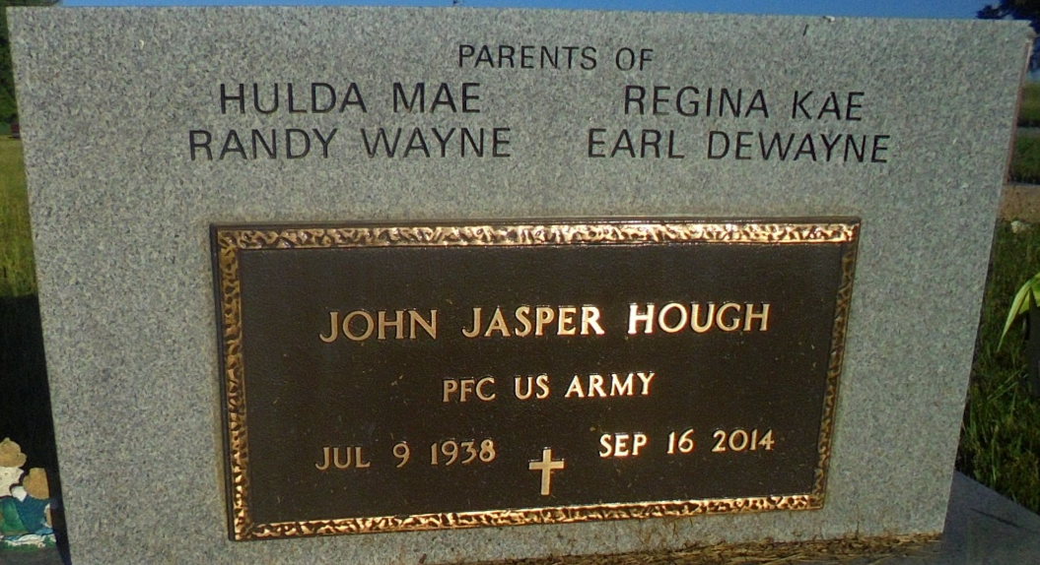
Photo by Margie Pearce

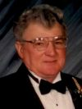
John Jasper Hough, 76, of Bryant, IN, passed away on Tuesday, September 16, 2014 at his residence in Bryant, IN. He was born on Saturday, July 09, 1938, in Adams County, IN. He married Judith Guntle on Friday, October 28, 1960 in Bryant. John had at Dunbar furniture, Steelcase Furniture, and he was a lifelong Adams County farmer. He liked to fishing, hunting and enjoyed wood working.
John is survived by his Daughter - Hulda (husband, Roger) Harter, Montpelier, IN., Daughter - Regina (husband, Keith) Huey, Geneva, IN., Son - Randy (wife, Rebecca) Hough, Geneva, IN., Son - Earl (wife, Lesley) Hough, Berne, IN., Sister - Caroline Jones, Bryant, IN., Brother - Lonnie (Wife - Carolyn) Hough, Indianapolis, IN., Brother - Tom (wife, Marilyn) Hough, Geneva, IN., 13 Grandchildren, and 12 Great Grandchildren.
Preceding him in death were his Wife - Judith Ann Hough, Father – Burley Hough, Mother – Hulda Hough, Brother - Joe Hough, Sister - Bernice Teeple, Brother - Robert Hough, Brother - Burley Hough, Brother - Jack Hough, Sister - Carolyn Whittwer, Brother - William Hough, and one Grandchild.
Family and friends may gather to share and remember at Downing & Glancy Funeral Home 100 N Washington Street Geneva on Saturday, September 20, 2014 from 2:00 PM to 8:00 PM.
A service to celebrate John’s life will be at Downing & Glancy Funeral Home 100 N Washington Street Geneva at 2:00 PM on Sunday, September 21, 2014 with the Rev. A. Jim Schwartz officiating. Interment will follow in the Daugherty Cemetery in Bryant.
Preferred memorials: Riverside Mission C/O Hulda Harter 10937 W. 900 N, Montpelier, IN 47359.
Arrangments are being handled by Downing & Glancy Funeral Home in Geneva.
Online condolences may be made at www.glancyfuneralhomes.com
Downing & Glancy Funeral Home, Geneva, Indiana online obit (accessed 9/17/2014)

