June (Salmon) Hough

May 30, 1941 – June 4, 2011

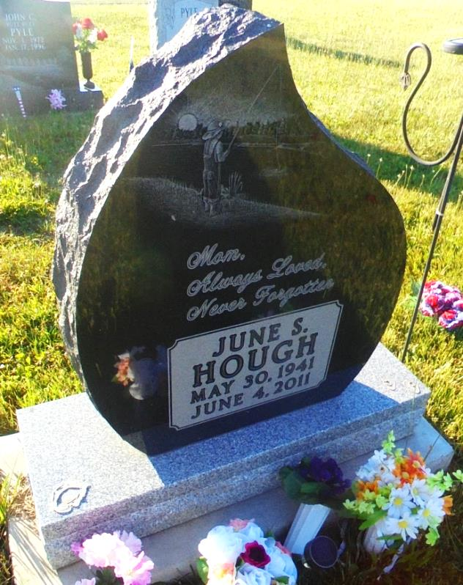

Photo by Margie Pearce

June S. Hough, 70, of Big Turkey Lake, rural LaGrange, passed away at 10:35 a.m. on Saturday, June 4, 2011, at her residence.
She was born on Friday, May 30, 1941, in Portland to Donald Salmon Jr. and Helen Crawmer Pyle, who are deceased.
June attended First Christian Church in Albany, Indiana, and New Corydon Grade School and Bryant High School. She was employed by General Electric Co. in Decatur for 10 years. She was a resident of the Jay-Adams county line before moving to Big Turkey Lake.
Surviving are two sons, Joseph Allen Hough of Big Turkey Lake and Jerry Lee Hough (and wife Kim) of Angola; one daughter, Mrs. Terry (Juanita Sue) Sisson of Terre Haute; two brothers, Donald R. Salmon Jr. (and wife Beverly) of Berne and John D. Pyle (and wife Cindy) of Geneva; four sisters, Norma Jean Smitley of Dunkirk; Thelma Marie Kongar and Jennifer Kay Schisler of Pennville; and Mrs. Larry (Roberta Ann) Maloney of Linn Grove; 12 grandchildren; and 11 great-grandchildren.
She was preceded in death by one son, Jack D. Hough, and by her husband, Joseph Hough.
A service to celebrate June's life will be held at Downing and Glancy Funeral Home, 100 N. Washington St. in Geneva, at 11 a.m. Wednesday, June 8, 2011, with Pastor Sally Jones officiating.

Decatur Daily Democrat (IN) - Monday, June 6, 2011

Contributed by Jane Edson

