Bertha Gertrude Huey
1877 – April 1, 1945

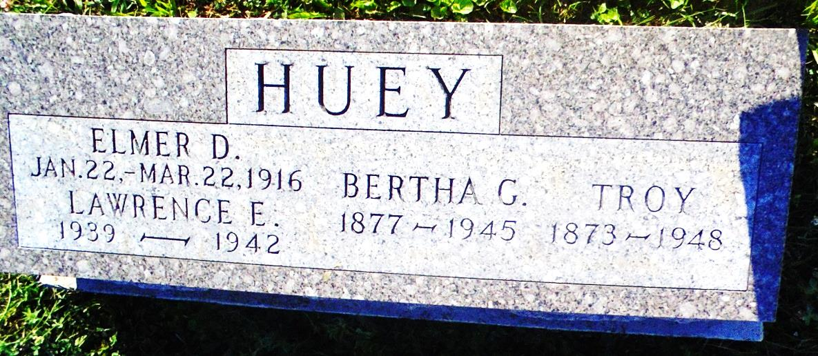
Photo by Margie Pearce

MRS. BERTHA HUEY DIES AT HOSPITAL

Mrs. Bertha Gertrude Huey, 68, of near New Corydon, died Sunday at the Adams county memorial hospital. Surviving are the husband, Troy; three daughters, seven sons, one brother, one sister and 40 grandchildren.
Funeral services will be held at 2 p.m. Thursday at the Yager funeral home in Berne, with the Rev. W. F. Johnston officiating. Burial will be in the Daughterty cemetery in Jay county.

Decatur Daily Democrat, Adams County, Indiana; Monday, April 2, 1945

Contributed by Karin King

