Billy Edmund Kelly
April 26, 1928 – July 27, 2001

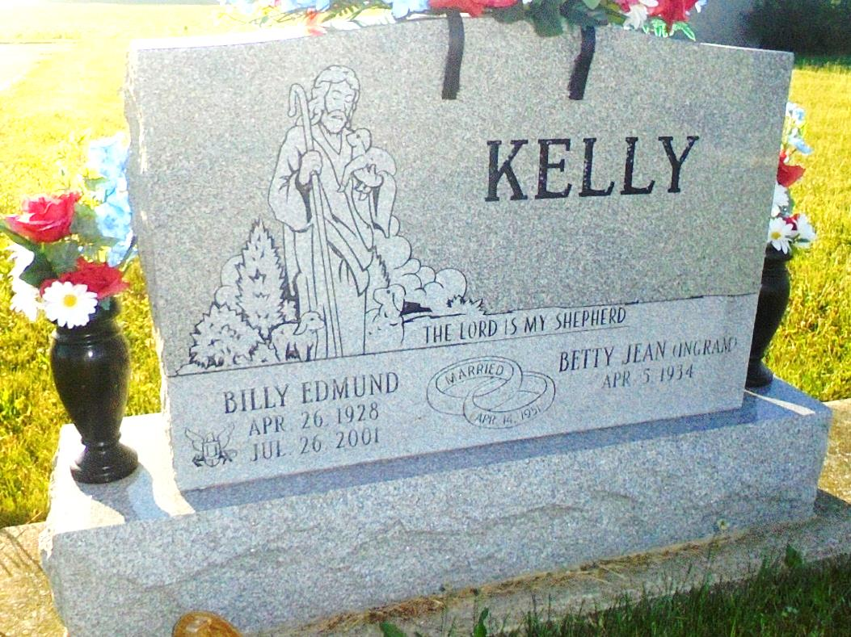
Photo by Margie Pearce

BILLY EDMUND KELLY, 73, died Thursday at Select Specialty Hospital, Fort Wayne. Born in Jay City, he retired in 1995 from Joyce Dayton Corp. after 22 years. He had also worked at Harshman Buick Garage for 18 years and Arm's Body Shop for 10 years, both in Portland. He was a World War II Navy veteran. Surviving are his wife, Betty Jean; two daughters, Rhonda R. Goss of Bryant and Tina M. Kelly of Portland; two sisters, Wilma Dugan of Portland and Evelyn Thurston of Van Wert, Ohio; a brother, Eugene of Sebring, Fla.; and two grandchildren. Service at 2 p.m. Sunday at Portland First Church of the Nazarene. Calling from 2 to 8 p.m. today at Williamson & Spencer Funeral Home, Portland Chapel. Burial in Daugherty Cemetery, northeast of Bryant. Memorials to Missions of the church.

Journal Gazette, The (Fort Wayne, IN) - Saturday, July 28, 2001

Contributed by Jane Edson

