George F. Longenecker
December 24, 1871 – October 4, 1897
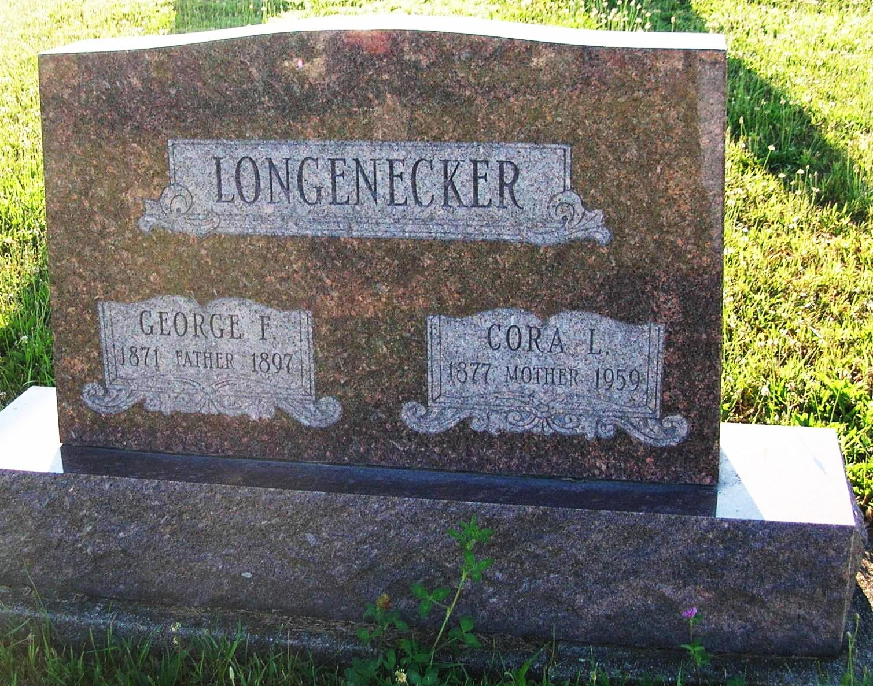
Photo by Jim Cox

George Longnecker died at his home four miles northeast of Bryant today, aged 24 years. Funeral tomorrow at 10 o’clock.
Portland Daily Commercial, Jay County, IN; October 4, 1897
Contributed by Jim Cox

